Tutankhamun’s Biography

Tutankhamun was born around 1341 B.C He was best known for the name boy king. Tutankhamun’s real name was Tutankhaten but he changed his name to Tutankhamun because he worshiped the moon god called Amun which changed his name to Tutankhamun. At the age of 9 he became a Pharaoh which gave him the name Boy King. Tutankhamun’s father was called Akhetan his mother was called Kia and his step-mother was Nefertiti.

Childhood.

When he was a lot younger he attended Prince School and had the lesson of maths, reading, writing, history. For tea he would have beef, gazelle and antelope. When Tutankhamun played sports he would hunt and would do fishing.

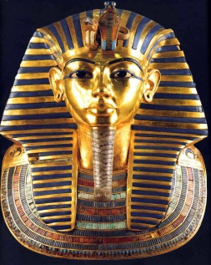
The reign of Tutankhamun.
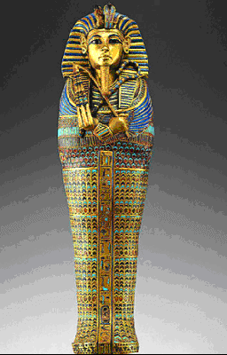
At the age of 9 Tutankhamun became a young Pharaoh which gave him the name Boy King it was quite unusual at such a young age. He also married his half-sister which was his cousin as well called Ankhesenamun. Together they had 2 children but unfortunately they both died young.

Tutankhamun’s death
Tutankhamun died at the age of 18 and his body was mummified which is how the Ancient Egyptians preserved there dead. Tutankhamun died of a broken leg blugged to death or a bad illness.

Conclusion
Tutankhamun lived a short life. He was most famous for his death mask. Tutankhamun’s tomb was buried in the Valley of the Kings and was in a smaller tomb. He was buried with five million pieces of gold in his tomb.

Lily

