Tutankhamun was first known as Tutankhaten and was born in 1343BC and died in 1328BC. He became pharaoh at the age nine years old and died at the age nineteen years old so he ruled for ten years. He was famous for being the boy king. Tutankhamun was born in Amana the capital city of Egypt and was buried in the Valley of the Kings.
Childhood
People think Tutankhamun’s father was Arkenaten but are unsure about his mother. They think it’s Kia or Nefertiti. Tutankhamun lived in a palace in the capital city of Egypt it was called Armana. When he was nine he began to be pharaoh.
Becoming pharaoh.
Tutankhamun began his reign when he was only nine years old. Tutankhamun was a boy king and reigned for ten years.
Marriage
Tutankhamun married his half -sister at the age nine years Tutankhamun had two children and they both died early ages.
Death
Tutankhamun died in 1328BC and when he died he was only 18 years old. His golden coffin was buried in a tomb in the valley of the kings and was surrounded by 5,000 priceless treasures.

Conclusion
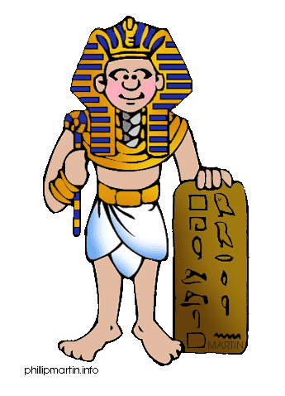
Now you know everything about Tutankhamun’s life. Hope you enjoyed it if you did please come back and read on more.

