Tutankhamun was first known as Tutankhaten and was born in 1343 BC he became pharaoh at 9 and died in 1323 BC. When he died he was 19 so he ruled for 10 years. He was famous for being the boy king. Tutankhamun was born in the capital city of Egypt that is called Amarna and was buried in the Valley of the Kings.
Tutankhamun’s family
Tutankhamun’s family was decently small and dad was formally known as Amenhotep the 4^{th.} His mum was either Nephite or Cia we are unsure of his mum’s identy .He had six sisters , one brother and a half sister.
Childhood
His childhood was ok because he became pharaoh .His name means the living image of amun the god. He became pharaoh when he was nine years old. This is when when he became the boy king.
Death
His death was at the age of nineteen and his death is unknown . He was either bludgeoned or his leg was broken and it was poisoned. He was most likely bludgeoned because there were bone fragments in his skull.
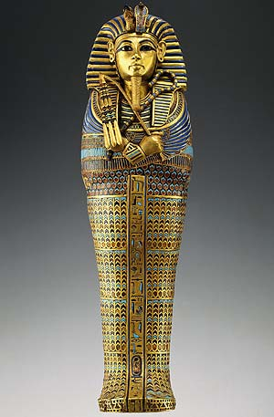
Conclusion
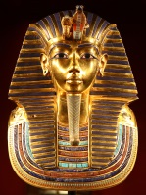
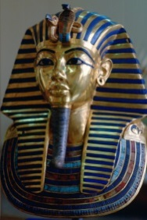
So that is all you need to know about Tutankhamun. There is a lot more info on the internet. Go and look at it there are a lot of things.

