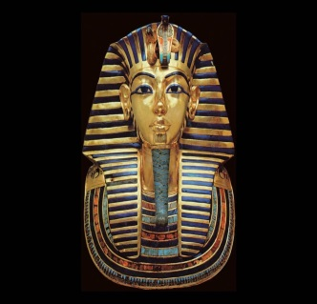
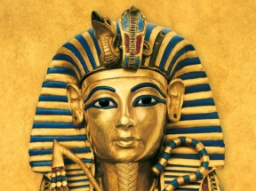
Tutankhamun was born around 1341 B.C in Armana. His parents were Akhenaten and his mother was believed to be Kaya. He was a pharaoh at 9 years old so he was called Boy King. He was also called King Tut at 11. He was the 12th king of Egypt’s 18th dynasty.

Childhood
When Tutankhamun was a child he was like all the other children in Egypt but he went to prince school and he learned how to throw spears, write, and maths. He did fishing for fun and drove his chariot around his arena. When he was 4 he ran around naked playing tag, stuck in the mud and man hunt. Tutankhamun was not actually called Tutankhamun because he was called Tutankhaten but he changed it when he became pharaoh.
Pharaoh
Tutankhamun became a pharaoh at 9 years old and also married his lovely, kind step sister at the same age! He was called a boy king because a lot of the sons of the pharaohs became a pharaoh at 15 or 14. He got a very powerful dagger when he became pharaoh it was made out of iron from a meteorite and his handle was gold. He sent out a servant to find it and he come back with it. When he was pharaoh he had a lot of servants and riches.

Death
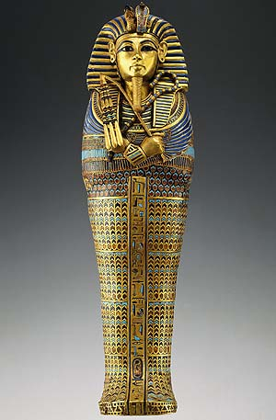
He only lived up until 19 years old before he died. He died with a Brocken leg or he got poised by a black mamba. He had the smallest tomb but he was buried with 5000 jewels and his dagger. He was also buried next to his lovely, golden and gigantic chariot. He is now one of the most famous pharaohs of Ancient Egypt.
Conclusion
Did you know that Tutankhamun ruled for 10 amazing years? I hope you now know about Tutankhamun and his life. Tutankhamun had a very short life in Egypt and by his tomb there was 5000 blocks of gold in his tomb.

