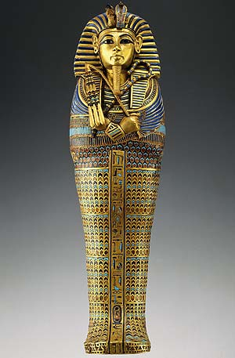
Tutankhamun was born around 1341 B.C, and was the 12th king of the 18th Egyptian dynasties whilst he ruled as a pharaoh for 10 years. People believed his father’s name was called Akhenaten. We are unsure of the identity of his mother. He died at the poor age of 19. After his death he disappeared from history until his tomb was revealed in 1922.
Name
He was given the name Tutankhaten meaning the living image of Aten who was the god believed in that time. He took the power of the boy king of his name and changed it into Tutankhamun which meant the living image of Amun. He was the god that changed his name into Tutankhamen.
His mother
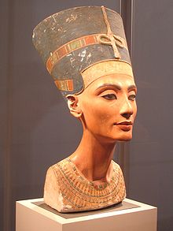
There appears to be a lot of mystery surrounding King Tut’s mother’s life. So who was King Tut’s mother? Many Egyptianlogist concur that it is most likely to be Nefertiti who was the most famous queen often defied with Akhenaten and logical could be Tutankhamun’s mother. Or the other option was Kia who was the wife of Arkanaten.

James Bennett
His reign
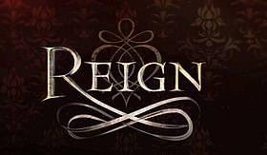
Tutankhamun was nine years old when he became Pharaoh, and he reigned for about ten years. Historically, Tutankhamun is significant because he was so young during his reign, and he also had a gold dagger. During his reign he also married his half-sister.
Conclusion
So that was Tutankhamun’s life. If you didn’t know, he either died from a broken leg or a serious poison. The poison could have come from a drink or a plant or some type of food that he ate and did not realise.

James Bennett

