  - The Life of the Boy King
Tutankhamen was born in 1341 BC in Ancient Egypt. He had two mums, one was a step mum and one was just a normal mum. They were called Neffiti and Kiya. Also his dad was called Arkhaeten. He was called the boy king because he became king at the age of 9. Sadly, he died at the age of 19.
Childhood
Tutankhumen was rasied in Amara. He went to prince school which teaches you before you become pharaoh. When he went to prince school he learnt to throw a spear and ride a chariot. Also much more fun things like playing ball and fishing.
Pharaoh and Getting Married
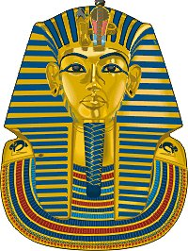
Surprisingly, at the age of 9 he became pharaoh. At the age of nine he married his half-sister . He had two children which were girls also they were his daughters.
Death
Tutankhamen either died by a broken leg and it got poisoned. Also people think he got hit around the head and his head broke. After he died he disappeared from history.Until someone found his tomb.
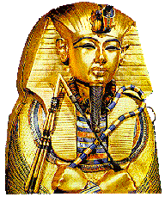
Conclusion
So now you know about the amazing Tankhamun. He died in 13223. He had two mums. His amazing reign made Egypt a perfect place . He made new laws which made Ancient Egypt a safe place for people to live.

