Tutankhamun was born in 1341 b.c he was born in Amara. His dad was Akhenaten and his half-sister was Arkenssenpaten and nobody knows his mum
Childhood
Tutankhamun became pharaoh when he was nine and went to prince school he learnt maths, English and much more when he was ten his dad died so he was not prince he was about to be king . He loved to fish and he got his hear shaved and got makeup on his eyes too all the boys in Egypt had makeup but some girls don’t.
King
He became king when he was nine and then he got married his half-sister and he got a dagger that was iron in Egypt and had two children and one of his hobbies was fishing
When he died
Tutankhamun died with a broken leg and died when he was nineteen he got buried in a gold coffin with his children then got put in his king he got buried in the pyramid

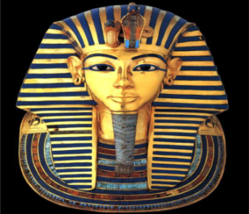
Conclusion
That was Tutankhamun’s life. I hope you learnt about his life .Did you know you are only allowed to stand by Tutankhamun for 30 sec’s?
iii f
Foor
f for fo

