**Communication and Language**

We will be turning our role-play area into a minibeast world, using our imaginations. We will also be inventing our own drama plays based on our topic and reporting about the minibeasts that we find.

**Literacy**

We will be finding out about minibeasts by learning how to find information in non-fiction books. It is now really important that your child can form every letter of the alphabet correctly starting and finishing each letter in the right place. We will also focus on spelling high frequency words in our writing correctly. We also need to sound out longer words correctly when we are writing them, so that others can read our writing without us telling them what it says.

**Understanding the World**

We will be finding out about life cycles, minibeast habitats and the food that they eat through going on minibeast trails around the school. We will make observations of the minibeasts looking for similarities and differences. At home investigate minibeast habitats in your garden or local park. See if you can sort the minibeasts you find into groups, noting their similarities and differences. We will visit Bristol Zoo’s Education Centre on Thursday 21st May to learn more about minibeasts.

**Mathematics**

During term 5 we need to know how to count on and back using every number to 20. We will be adding and taking away and also doubling, halving and sharing using numbers up to 10. We will be measuring and comparing lengths, solving practical problems and looking at money. At home practise counting forwards and backwards, starting from different numbers up to 20. Try to find as many different solid and flat shapes as you can around your home. Keep a chart of the number of shapes that you find, and count which has the most.

**Physical Development**

We will be developing our skills using small equipment such as bats, balls, hoops, bean bags and skipping ropes. At home try to help your child throw a ball underarm. Can they consistently catch a small ball with two hands?

**Minibeasts**

**Term 5 – 2015**

**Reception Class**

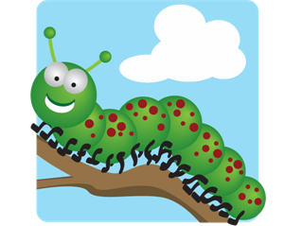

**Expressive Arts and Design**

We will be making collages and masks of different types of minibeasts. We will also be completing observational drawings of different minibeasts that we find around the school buildings and grounds, using chalks and charcoal. At home, get your child to make a junk model minibeast or a symmetrical butterfly choosing their own resources.

**Personal, Social and Emotional Development**

We will be finding out how to look after minibeasts in the local environment and in the classroom, and discussing the right and wrong ways to treat animals. We will also be thinking about the relationships we have with different people.