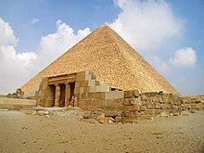
Tutu khan was born in 1341 in a hatch when he was 19.
Tutankhamun went to school when he was only 9. He learnt how to fish all by himself so he could eat. Tutankhamun has changed his name from Tutankhaten to Tutankhamun. He was called Tutankhaten because his dad wanted everyone to believe in the god Aten but when he became
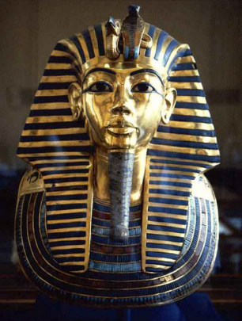
Ancient Egypt. He had two mums one was a step mum and was a normal mum.They were called Nefertiti and Kaiya also his dad was called Akhentaten. He Pharaoh he changed the leader of the gods to Amun.
When he became Pharaoh he was only 9 years old. He ruled for 10 years and married his half - sister when he was 9. Scientists think his dagger was made from a meteorite but no one knows where he got it from.
