The Biography of Tutankhaten/ Tutankhamun.
Tutankhamun was born in 1341 B.C. in a city called Armanda which his father then called Amana. Tutankhamun’s father was called Akhenaten but nobody knows who his mother was out of Nefertiti or Kiya. He became pharaoh when he was 9.
Tut’s father
Tutankhamun’s father built temples to worship Aten the Ancient Egyptian god. He built the capital city around it which he called Amana. Aten was the Ancient Egyptian sun god.
Childhood
Tutankhamun went to a good he went to prince school. He learned about history, maths and how to write. He went fishing for fun and road his chariot around his arena.
Pharaoh
Tutankhamun became a pharaoh at the young of 9. Tut changed his name to The Boy King. He ruled as pharaoh for 10 years. He was called The Boy King because most people became pharaoh when they were 14-15.
Tutankhamun’s marriage
Tutankhamun married his half-sister Arkenssenpaaten. He married her while he was pharaoh. He also married his cousin called Ankhesenamun and together they had 2 children but they unfortunately died when they were young.
Death
Tutankhamun either died from illness or an infected leg. He died when he was 19. There was no more information found about his death . But he was buried with over 5000 pieces of gold. He was buried I the valley the kings.
Conclusion
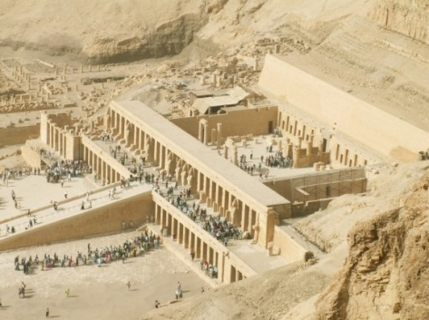
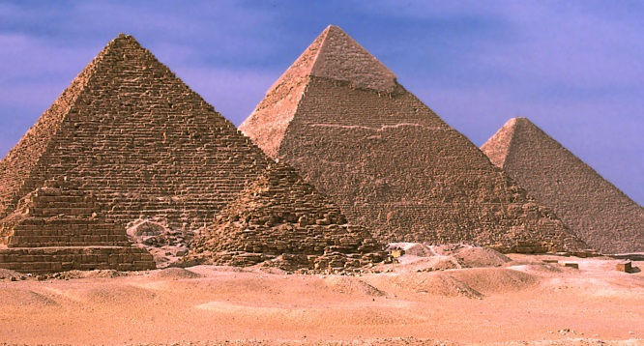
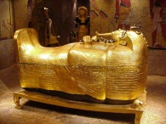
Tutankhamun lived a short life. He was very famous because of his death mask. Did you know he died in 1322 B.C. ? After his death, Tutankhamun disappeared from history until his tomb was discovered in 1922.
V

Ollie

