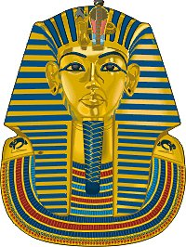
Tutankhamun was born around 1941 b.c he was best known for the name because he boy king. Tutankhamun’s real name was Tutankhaten because his dad forced him to worship the Sun God but he changed it to Tutankhamun because he started worshiping the Moon God called Amon. At the age of 9 he came Pharaoh. Parents. His half-sister was Arkenssenpaten he married his half-sister while, being Pharaoh and he was the 12 king. He had to stillborn daughters.
When he was in his childhood he went to prince and learnt hieroglyphics math reading history. For sports he did chariots archery fishing on the Nile. As swell as girls, boys wore more makeup. He restored Egypt to polyether.
Tutankhamun was used to be called Tutankhaten because he was taught to worship the sun god. Instead he worshiped the moon god so his name was Tutankhamun. His dad was the only parent and he teachered him to worshiped the sun.
When he was a Pharaoh, he married his half-sister. Tutankhamun was Pharaoh for ten years and died at the age of nineteen because he broke his leg. His tomb was discovered in 1922 and he had lots of gold in his tomb.
So, Tutankhamun was really interesting. Did you know that Tutankhamun was not famous for being Pharaoh? He was famous for his tomb.

