Homework- 13.4.18
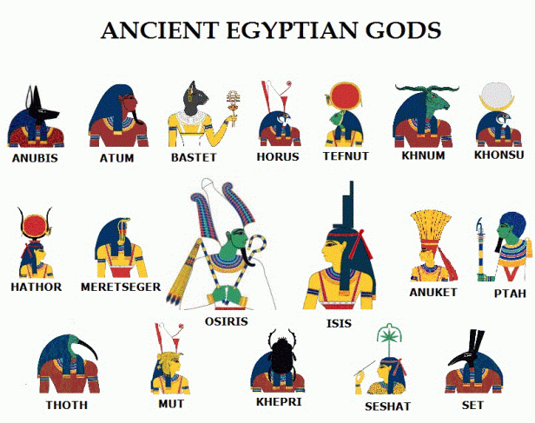
Over the next couple of weeks I would like you to research an Egyptian God. Pick one god and present all the information you have found out about them. You can choose how you present the information (a poem, a poster, a model). Be creative! You will need to share your findings with the rest of the class the week commencing Monday 30th April.

Homework- 13.4.18
Over the next couple of weeks I would like you to research an Egyptian God. Pick one god and present all the information you have found out about them. You can choose how you present the information (a poem, a poster, a model). Be creative! You will need to share your findings with the rest of the class the week commencing Monday 30th April.

