History  Kings and Queens  We will be learning about British monarchs in history, as well as asking the children to draw comparisons between Elizabeth I and Queen Victoria. We will develop our awareness of the past and use timelines to compare different periods in history. We will be making links to our Royal family and the wedding of Prince Harry and Meghan.  Castle life  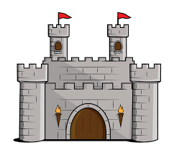  We will be taking a trip to Berkeley Castle on Tuesday 19th June. We will be answering questions like: Why do we have so many castles in the UK? How and why were they built? What are the main features of a castle? |  |  | Physical Education  Future Stars – Y1 and Y2 will be developing their skills with Rich the PE coach.  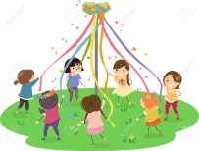  REAL PE – We will continue to develop our travelling, balancing co-ordination and ball skills.  We will also be practising for our Summer Sports Event (July) focusing on athletic skills.  We are looking forward to using the Maypole for a spot of May day dancing! |  | Computing  Y1 - we will learn how to search on the internet to find out information about our project developing our web skills. We will research an historical person and use this to make a class video.  Y2 – We will be looking at data and how it can be presented to allow it to be interpreted. We will gather the data and then select the most appropriate method to display it. |  |  | Science  Materials  We will investigate the suitability of a variety of everyday materials for specific purposes. We will test which material is best to protect an egg.  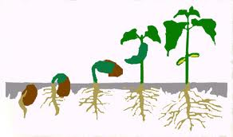  Different materials have different properties and so we will try to understand why each material does a different job.  Plants:  We will be identifying and naming common wild and garden plants, including deciduous and evergreen trees. We will describe the basic structure pf common flowering plants. We will observe and describe how seeds and bulbs grow into mature plants. We will also find out how plants need water, light and a suitable environment to stay healthy.
Maths  We will be following the White Rose mastery maths planning to develop our skills in the following areas: |  |  |  | Year 1 and 2  Term 5-6 2017/18  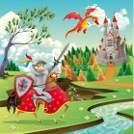  Dragons and Drawbridges  Mrs Philpott, Miss Gibbs and  Mrs Browett |  |  | English  Dragons - Fiction  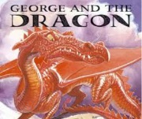  Using stories about Dragons, we will identify adventurous vocabulary and use these in our own writing. We will be developing our sentence writing skills and sequencing these to write a dragon story. We will practise spelling, applying the spelling rules and using phonics.  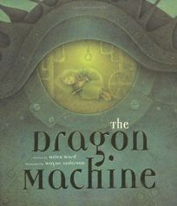  Non-fiction  We will be looking at the organisational features of a variety of non-fiction texts and using these to make our own. There will be plenty of opportunities for us to write instructions, captions and labels across the curriculum. Following on from a role play activity, we will be planning our own ingenious ways of how to trap a dragon and writing instructions for how to do this.
Year 1:  Place Value  Four operations (+, -, x, ÷)  Fractions  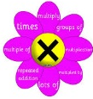  Money  Weight and Volume  Length and Height | Year 2:  Multiplication and Division  Fractions – half, thirds, quarters.  Position and Direction  Time – o’clock, half past, 15 minute intervals, 5 minute intervals  Reading Scales in divisions of 2,5,10.  Solving word problems using the four operations (+, -, x, ÷)
RE  We shall be celebrating St George’s Day on April 23rd by recounting the story and looking at various artistic representations of St George and Dragons.  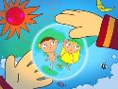  Following on from this we will find out why some stories are special to us and our families and what stories and books are special to people with religions and special beliefs. We will also think about the way that stories are used to tell us about the lives of special people. |  | Music  Y2 will be learning songs and taking part in the cluster schools Summer Music Festival.  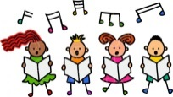  Y1 will be focussing on a song called ‘Your Imagination’. Following a step by step approach we will learn and sing the song, listen to and appraise different types of music and will use percussion instruments. We will use different techniques to make our own music. |  |  |  | Art  Drawing skills and improving drawings.  Sculpture – Using clay to make own dragons  Design and Technology  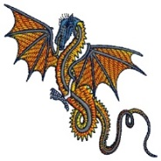  Design own dragon machine. |  |  | Geography  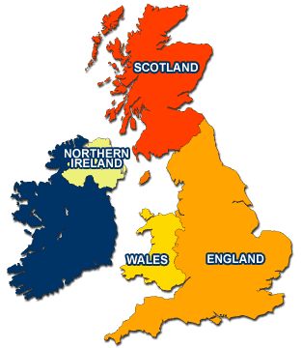  We will be naming and locating the 4 countries of the UK and their capitals. Whilst studying maps we will try to understand he difference between human and physical features on maps, atlases, globes and satellite pictures. We will make our own maps and use keys to help you read them.

