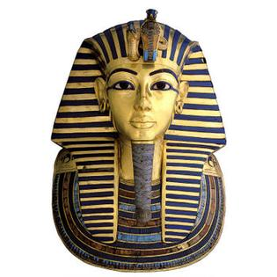
The Life of King Tut
Tutankhamun was born around 1346BC.He was best known for the gold in his tomb but some people know him for his nickname the Boy pharaoh. Tutankhamun’s real name was Tutankhaten but he changed his name to Tutankhamun because he worshiped the moon God called Amon which changed his name to Tutankhamun .At the age of 9 he became a pharaoh which gave him the name King Tut. His father was named Asheton his real mother was Kaya and his step mother was Nefertiti.
Child hood
When Tutankhamun was a child he went to prince school where he learnt hieroglyphics Maths charting and throwing spears. He lived a house called Amucqwenwe . Tutankhamun liked playing leap frog with his friends
His rule
Tutankhamun became pharaoh at the age of 9 and was now known as the King Tut. During his reign King Tut happily married his step sister in the same year he became pharaoh. Tutankhamun had two daughters but sadly they died when they were very young
His death
King Tut died at the age of 19. Because Tutankhamun died just before a war people thought he was killed by an enemy. Tutankhamun died because of a broken leg that got gangling green and died.
Conclusion
King tut ruled for just 10 years. He was the 12 pharaoh. His tomb was really small with tons of gold.
By Isobel

