A Biography of Tutankhamun
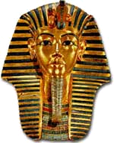
Tutankhamun was born around 1341 BC and was the pharaoh of Egyptians very early. His dad was called Arkhaten and his mother was called either Nefertiti or Kia, but we are not sure who she really was. Tutankhamun was known as the boy king.
Childhood
Tutankhamun had to grow up quickly. He went to prince school where he learnt javelin, English, fighting and lots of other stuff He started to wear more make up when he started school. He cut lots of people in his fighting class. He cut his hair because he was about to become pharaoh.
Becoming pharaoh
When Tutankhamun became pharaoh he was only 9 years old. He also married very early. He married his half sister. He really did not last very long on the throne as he died very young at the age of 19.
Burial
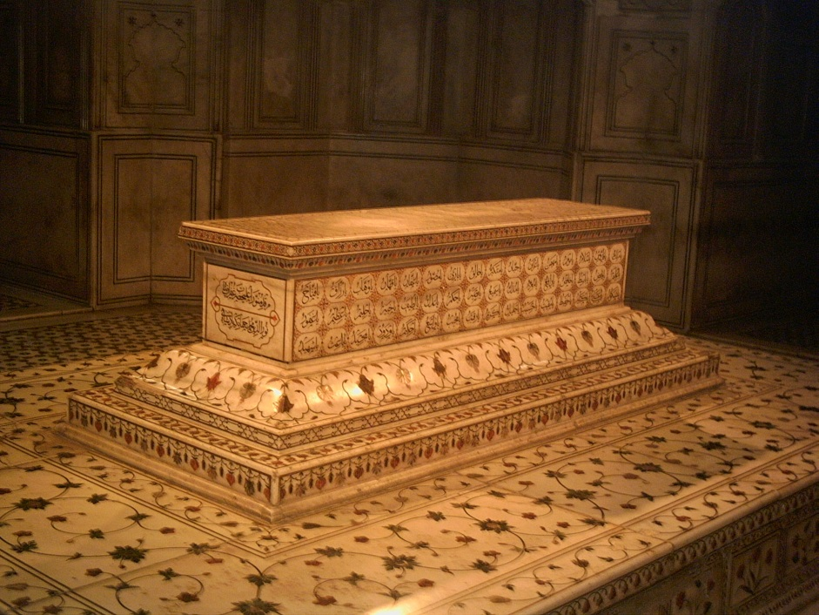
hTutankhamun was buried in the Valley of the Kings. His sarcophagus was mostly gold and silver. When they mummified him, they used sheep fur to make the bandages. He had a mask on his sarcophagus that resembled his face.
Conclusion
I hope you liked reading my biography and that you agree that Tutankhamun was a very important pharaoh. I am sorry that I can’t tell you anymore .Did you know Tutankhamun’s dagger was made of iron and gold although iron wasn’t found in Egypt. So this particular iron came from the moon.

Hazel

