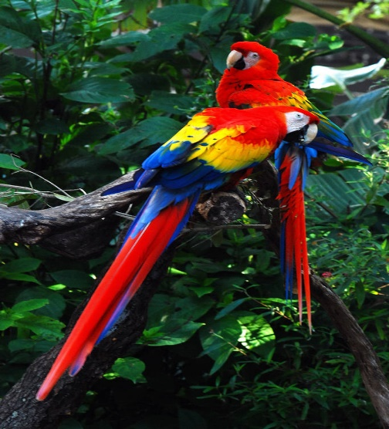
What is a rainforest
A rainforest is just as the name is it’s a forest that gets lots of rain. There is more animals than humans in the rain forest. Do you want to learn more if you do read?
  - What lives in the rain forest
Lots of animals` humans and plants live in the rainforest. Animals such as snakes, frogs, tigers, jaguars and bats.

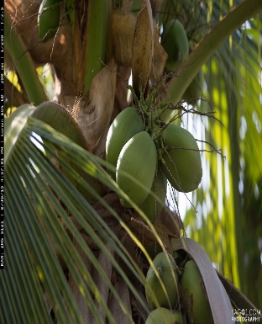
What grows in the rain forest?
Lots of trees and plants known as rubber tree, orchids, coco beans, coffee beans and nuts grow there. Did you know that all are bananas come from the rain forest. Most of the plants grow on the forest floor. All are pineapples come from the rainforest to.

what is the layers of the rainforest?
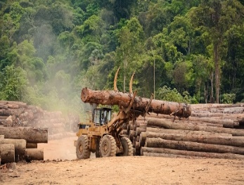
There are four layers the emergent layer the canopy under story and the forest floor. All of the layers are different. The emergent layer is the hottest bit of the rainforest high on the trees. Its home to bats butterfly’s and birds.
  - How is the rain forest getting destroy?
People cut and burn the trees every day to make football pitches. They don’t even want the wood. And the animals are getting forced out of their homes.

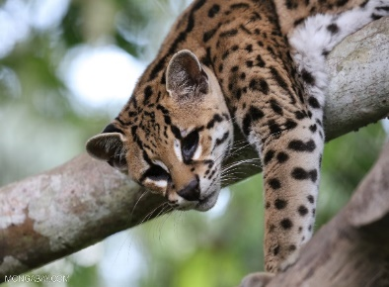
Concluding paragraph
We need to protect the rainforest because it provides us with oxygen. And the animals would die. So it is our job to protect the rain forest.

