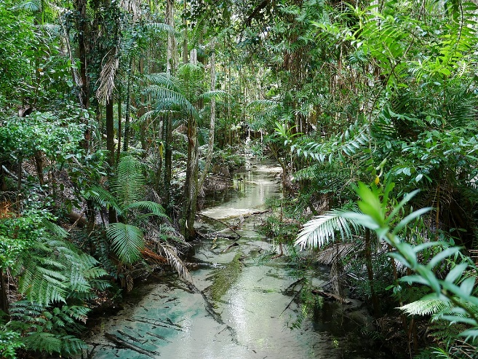
What is a rainforest?
It has four layers: The Emergent layer, the canopy the, understory and the forest floor. The Emergent can be up to 60m in height. It has animals such as: bats, birds and butterflies. The Rainforest is hot and humid. Cocoa beans, nuts, coffee, sugar, tea, avocado, sesame seeds, bananas and guava are grown there.
What lives there?-plants
There are 40,000 different plants are grown in the Rainforest. We own 8 acres of it. Over 50% plants on Earth live there. Rubber trees release latex as sap.70% of cancer treatment grows in the Rainforest.
What are the layers?
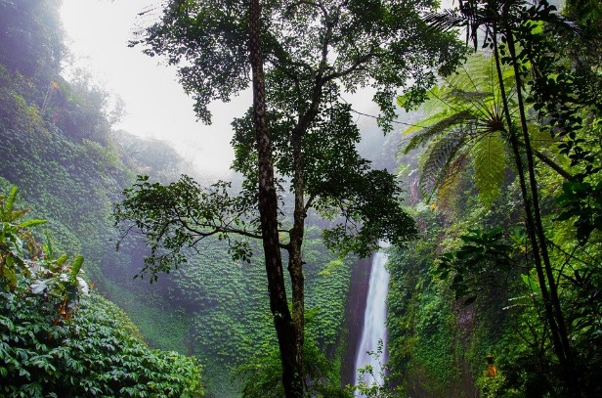
The layers of the Rainforest are: The Emergent, the Canopy, the Understory and the Forest Floor. The Canopy has lots of birds and animals such as: monkeys, hawks, falcons, eagles, bats and hornbills. It also acts as an umbrella to the Understory and the Forest Floor. Most animals live in the Forest Floor and Understory such as: leopards, anteaters, elk, bears and snakes. Not many plants grow on the Forest Floor because it is almost permanently black.
What lives there?-animals
There are 3,000 species of fish, 400 species of amphibians, 378 species of reptiles, 1,300 species bird and 427 species of mammal. There are also 2.5 million different insects. Howler monkeys actually howl.
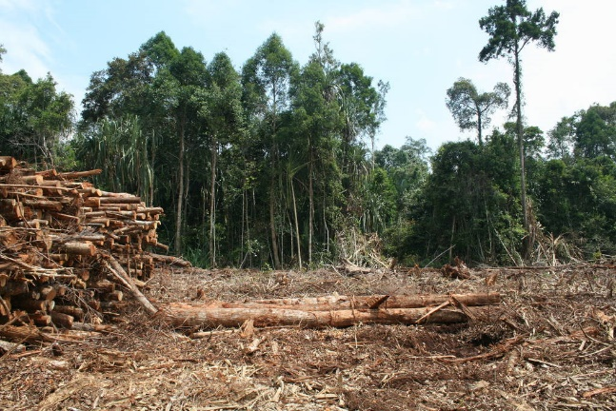
Why are we cutting down the rainforest?
The Canopy is being burned and cut down because we need palm oil. The Rainforest is being cut down a football pitch a minute. The biggest problem to the animals is the beef trade.
Conclusion?
50% of the air comes from the Rainforest. Trees turn carbon-dioxide into oxygen. So basically we’re killing ourselves. There are 390 billion trees in the Amazon Rainforest. It is probably the most famous, biggest and oldest Rainforest in the world. The Rainforest is being cut down so the animals are losing their homes.

