What is a Rainforest?
The rainforest is its name it’s a forest that gets a lot of rain. The average rain fall is 250-450cm of rain a year. There are 4 layers in a rainforest.
The 4 layers
There are 4 layers in a rainforest. The 4 layers are Emergent, canopy, understory and forestfloor. Emergent layer is the top of the trees with the most sun light. Canopy is were most animals live it also creates a thick roof. Understory is called (understory) because it’s under canopy it also does not have a lot of sun. Forestfloor has a little less sun then understory and it also called the (shrub layer) because it has a lot of little shrubs by rivers and streams.
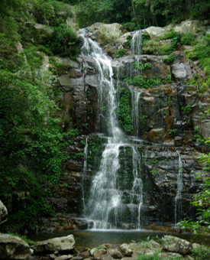
What grows in a rainforest?
There are lots of plants in a rainforest. Some are poisoness plants and not poisoness plants. Trees, shrubs and orkids grow in rainforests as well.

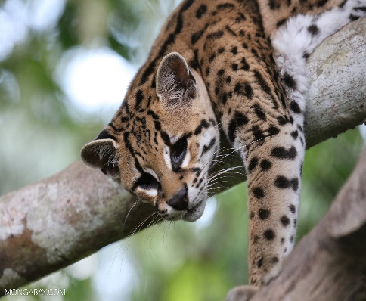
What lives in a rainforest?
There are a number of species in a rainforest. There are venomous and not venomous animals and there are poisoness animals also not poisoness animals in a rainforest. There are 400 amphibian types, 378 reptile types, 427 mammal types and 40,000 plant types.
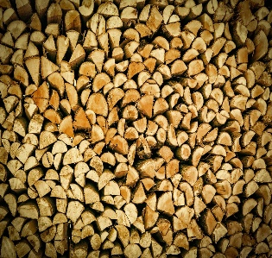
Deforestation
Over the years deforestation has been mager in rainforests. Every minute 1 football pitch of a rainforest is gone. Some people just cut or burn the trees in forests and Rainforest.

Concluding
Trees take in carbon dioxide and let out oxygen. NOT everything in a rainforest has been found. We have to take care of rainforest.

