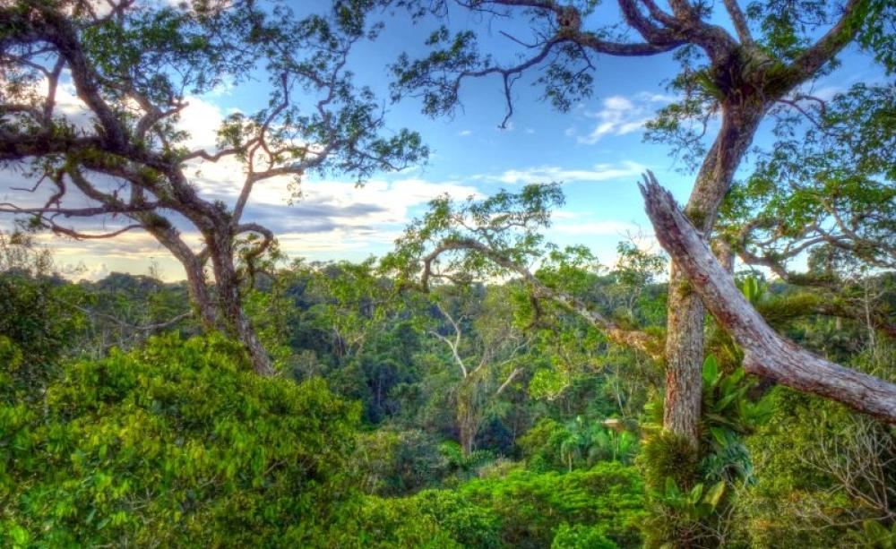
Rainforests
What is a rain forest?
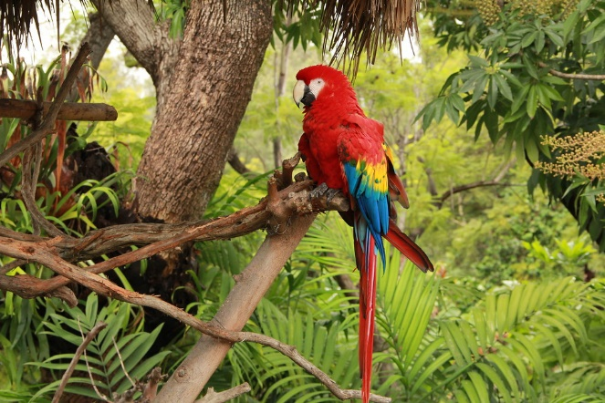
The rainforest gets lots of rain. The average is 250 cm to 450 cm every year. A rainforest is just as the same name means: it is just a forest that gets a lot of rain.
What lives there?
Most of the animals live in the understory. 300 pieces of fish it’s also a home to. Amphibian’s including the poises dark frog.
What are the layers?
The layers are the canopy layer, forest floor, understory and emergent layer. Monkeys actually live in the canopy layer to keep them safe because they are small animals. This keep them away from the big animals. Like elephants seeing as elephants have big paws
What grows at the rain forest?
There are a lot of trees. One of them is birch tree and oak tree and more. There is also vines and flowers. They are mainly there because it rains a lot and flowers need rain to grow and to survive
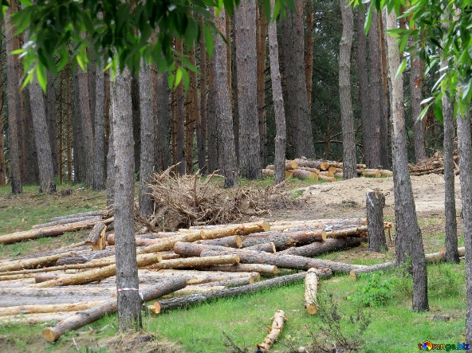
Deforestation
Climate change is worrying. The things that live at the rainforest especially animal’s plants and trees such as monkeys .Elephants tortoise and many more about 3.5000 to 7.0000 trees are cut down every year.
Concluding paragraph
We need to think about the carbon dioxide because. They take the carbon dioxide because oxygen is in the trees so they need to stop chopping the trees down because we breathe with oxygen.

