What is a rainforest?
A rainforest is a forest which never stops raining. A rainforest rains a lot every year but the amazon rainforest rains about 250 cm to 450 cm every year! You would probably think the rainforest is cold and dark but it’s very hot and it’s only dark if you’re under the canopy layer because the canopy layer steals all of the sunlight. Did you know that some people actually live in the rainforest and hunt for their food! These people are called indigenous!
What grows there?
In the rainforest about 40,000 different kinds of plants are there. Some trees in the rainforest seem tiny but when they grow they are GINORMUS! The rainforest is perfect for plants because it always rains and it’s very hot and sunny. Did you know that probably all the fruits and some food you have come from the rainforest like bananas, coco beans, avocados, lemons, grape fruit and coffee beans? In the rainforest the tallest tree is called a sumaumeira. Not a lot of coco beans are there so we might have NO MORE CHOCLATE.
Emergent Layers
In the rainforest here are different layers and they are forest floor, the understory, canopy and the emergent layer. On forest floor there are animals like jaguars, tigers and way more. The forest floor minutes for the rain to get to the forest floor because the emergent layer acts like a giant green umbrella.
Deforestation
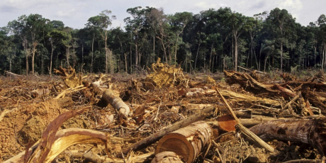
Many people cut down rainforest trees to build farms and houses and some just cut them down and burn them. About 3.5 billion to 7 billion trees get cut down every single day! If people keep cutting them down then we wouldn’t be able to make most medicine because about 114 of medicine items come from the rainforest. Lots of food we have and ingredients have been found in rainforest like banana’s and avocados and coco beans. If we cut down every tree in the rainforest then we would have NO CHOCATE FOREVER.

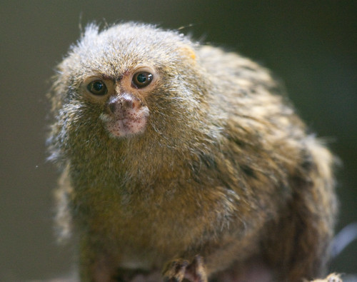
Animals that live there.
In the rainforest there are around 3000 species of fish. 400 species of amphibians including world famous poisonous dart frog. There are 317 reptile species and 1300 species of birds and 427 species of mammals. The cutest animal in the rainforest is a pygmy marmoset. Also if you wanted to adopt an animal from the rainforest like a sloth you can but you can’t just go to the rainforest and pick up a sloth and take it home. You need to have permission and have the right food and tools.

Why is the rainforest so important?
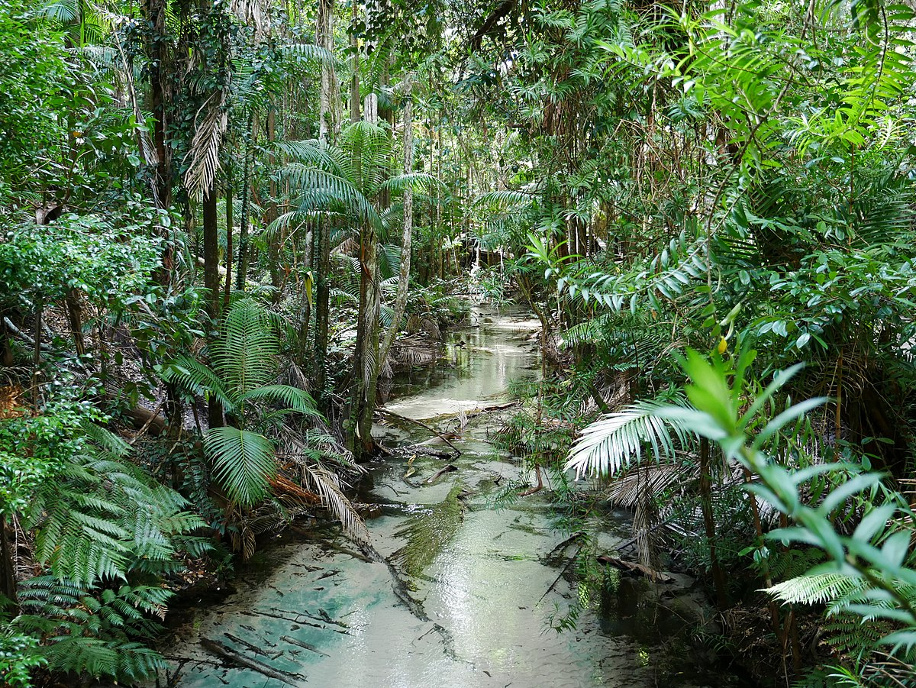
Rainforest give us most of are oxygen we need to live with. Lots of rainforest animals are losing their homes every day because people are cutting down trees and imagine someone just destroying your home and killing your family because they wouldn’t move. Nobody would want that to happen and the people who cut down trees wouldn’t want that so imagine how the animals feel. When people cut down trees they should get seeds and plant them back because it’s not very kind to the animals to lose their homes and lots of are food comes from the rainforest so if people keep cutting down we will have no more chocolate no more coffee no more bananas. I hope in the future people who cut down trees realize how it’s wrong so they stop.

