WHAT IS A RAINFOREST?

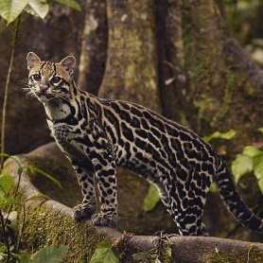
A rainforest is as its name and is a forest full of rain. The Amazon has 250- 450cm of rain each year. It has a moderate climate and it is never cold. It produces 50% of the oxygen that we use.

Animals
The Amazon has 3000 species of fish, 300 species of reptiles and 427 species of mammals. The animals live in different layers.
The layers
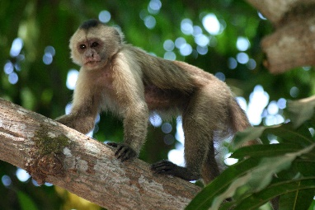
The layers called the emergent layers canopy under story forest FLOOR.IT can so cold on the floor.
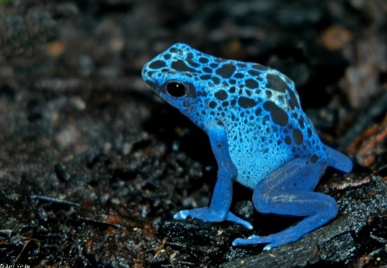
What Grows there?
In the Amazon avocados, oil and bananas grow. We need the forest to survive and oxygen to save the animals.

Conclusion
We need every kind of forest even the amazon rainforest and the normal rainforest. Like dark forest and the jungle those are for the oxygen. The oxygen is getting down.

