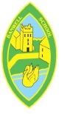You said...
At ‘Whole School Circle Time’ you said “We want to be caught reading for World Book Day”

“So, you brought in photos for the board. Mrs Lester had chosen a place for the winning photo, Ella Shepherd won”

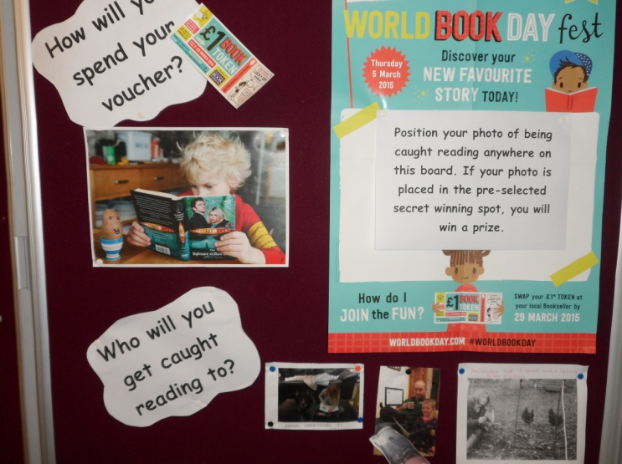

World Book Day  Spring 2015 |  | Actions  - The ‘Whole School Circle Time’ talked about what we could do for World Book Day.  - Our parents were told of our decision in the weekly school newsletter.  - We brought our photos in and put them on the board.  - Mrs Lester organised a prize of a book and a chocolate bunny.
 | Whole School Circle Time… making a difference

