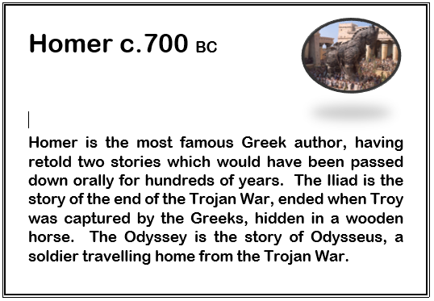
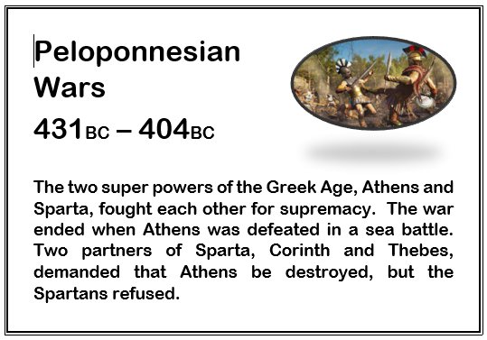
Knowledge Organiser: Ancient Greece
Ancient Athens
One of the two leading cities of the Classical Greek world. At the centre of Ancient Athens was the Acropolis (Greek for High Point), a hill that contained many of the key city sites, including The Parthenon. The Athenians are known for scientific discovery, for inventing democracy, and for the many theatres and cultural activities.

Ancient Sparta
Sparta is famous for its incredibly tough way of life. Children lived away from their families and were brought up to be fighters. Those which were not considered strong enough were left to die. As a consequence, they were formidable fighters, winning the Peloponnesian Wars.

Egyptian Empire
 |  |  |  |  |  |  |  |  |  |  |  |  |  |  |  |  |  |  |  |  |  | Roman Empire
Minoan |  | {} | Mycenean |  | {} | Archaic Greece |  |  |  |  |  | Classical Greece |  |  |  | Hellenistic Period
2000 BC – 1450 BC |  |  | 1750 BC – 1050 BC |  |  | 700 BC |  | 600 BC |  | 500 BC |  |  | 400 BC |  | 300 BC |  |  | 200 BC |  | 100 BC |  | 1 AD |  |  |  | 100 AD |  |  |  | 200 AD |  | 300 AD |  | 400 AD |  | 5oo AD
