What is a rainforest?
The rainforest is a forest that has lots of trees and grass. It rains a lot.
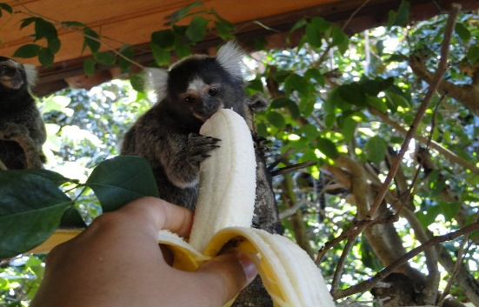
Layers of the rainforest
There are four layers of the layers of the rainforest which are called emergent layer, canopy layer, understory, forest floor. The emergent layer is the top layer. The understory and the forest floor are where most of the animals live. They live there because there is the most food there.
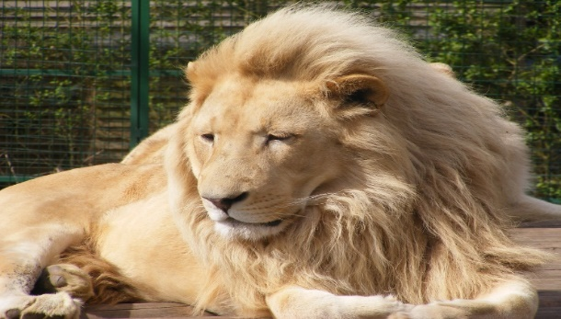
What lives there?
There are animals and snakes in the rainforest. There are over 3000 different types of fish. People called native or indigenous people live in tribes and some have not been discovered yet. The poisonous dart frog tell other animals not to touch with the marks on his back.
Plants and fruit.
We use coffee beans, coco beans, nuts and many more things that grow in the rainforest. Also we eat bananas that grow there. There are over 40000 types of plants in there.
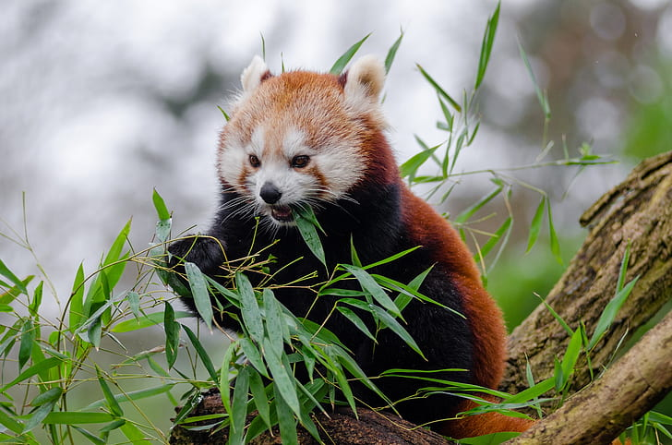
Conclusion
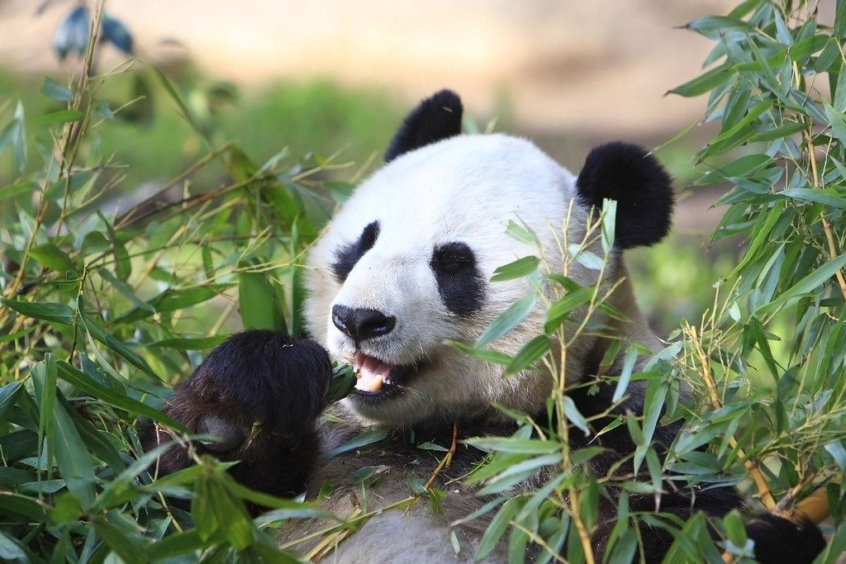
This amazon rainforest is big. There are lots of trees and animals . We need to protect the rainforest .

