**Science**

*Properties and Changes of Materials:*

● Investigate which materials would be effective for making a warm jacket / keeping something cold

*Living Things and Their Habitats:*

● How is Antarcticas’s wildlife adapted to its environment?

Forces:

Investigate resistance in water

**History**

● Develop an understanding of how our knowledge of the past is constructed

●Learn about Shackleton’s incredible expedition to Antarctica from various sources including diary entries

**Art, Design & Technology**

● Research cave paintings; focus on Lascaux Caves

● Use a range of materials to improve design techniques: design a cave painting

● Sculpt with a variety of materials – create a 3 d wolf

● design and make a shelter

**English**

Class Book: Wolf Brother

● Diary writing

● Drama

● Explanation text: Cave formation

● Non chronological report on wolves

● Write a quest story linked to Stonehenge

● Eloquence: Discursive focus: Should animals be kept in zoos?

● Eloquence: Oral storytelling

**Maths**

● Fractions,

●Decimals & Percentages

● Area and Perimeter

● Multiplication and Division

● Continue with X tables

**French**

● Develop vocabulary and key verbs, for basic conversational French; use for greetings to describe family life and interests.

**RE**

**PE**

● REAL PE – Cognitive focus on agility (reaction / response) and coordination (ball skills)

● Tennis / Tag Rugby / Netball

● Invasion games

**WOWS**

● Explore Banwell Bone Cave

●Visit to Wild Place, Bristol

●Investigate Stonehenge

●River project

●Outdoor activities e.g. collecting wood, making fires and shelters

● Oral storytelling around a fire

**We’re Going On A Bear Hunt…**

**A Stone Age Quest**

**Big Idea: Respecting yourself and others. Showing resilience and courage in everyday life.**

**Year 5** 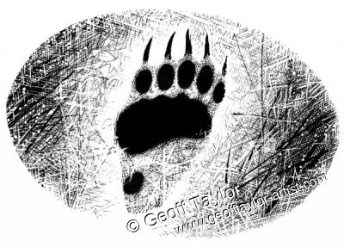

**Computing**

● E-safety

● Use a variety of software to design and create an animation on ipads

● Use the internet to research

● Make an e-book to present a story

**Geography**

● Cave & River formation

● Water cycle

● Locate rivers and hills on a map

●Use field work to observe, measure and record key features of River Banwell

●

●

**Music**

Jazz

Tunes: Three Note Bossa / The Five Note Swing

● Listen and appraise songs

● Play instruments

● Improvise

● Perform and share

● Christmas Carol concert