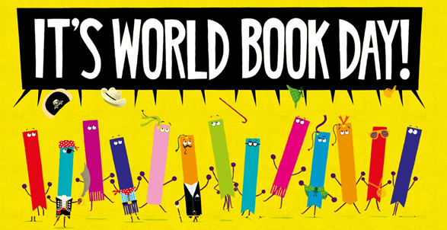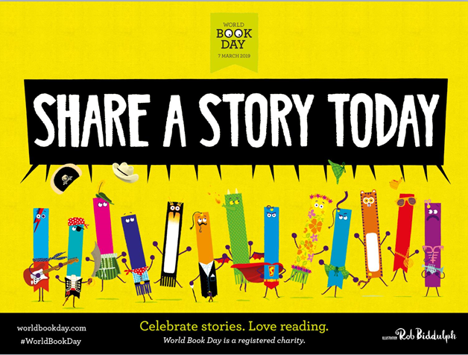

Dear Families of Reception, Year 1 and Year 2,

As part of our World Book Day celebrations, we would like to invite you to come into our classes and share a story with your child.

**Date: Tuesday 5th March**

**Time: 2.45pm – 3.10pm**

You may bring in a favourite book from home to share with your child / children or we will have many different books to choose from in the classrooms.

If you have children in more than one of our classes, you can choose which classroom to be in and your other child can come to you. Younger siblings are welcome but you will need to supervise them. If you have any questions, please speak to your child’s class teacher.

We look forward to seeing you at our Share a Story session on

Tuesday 5th March.

Kind regards,

The Early Years / KS1 Team