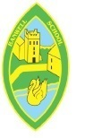You said...
“Why do so many children in Africa not go to school?”
“We found out reasons - there are not enough schools, they are too far away, older children have to stay at home to look after younger ones, they may have to go to work.”

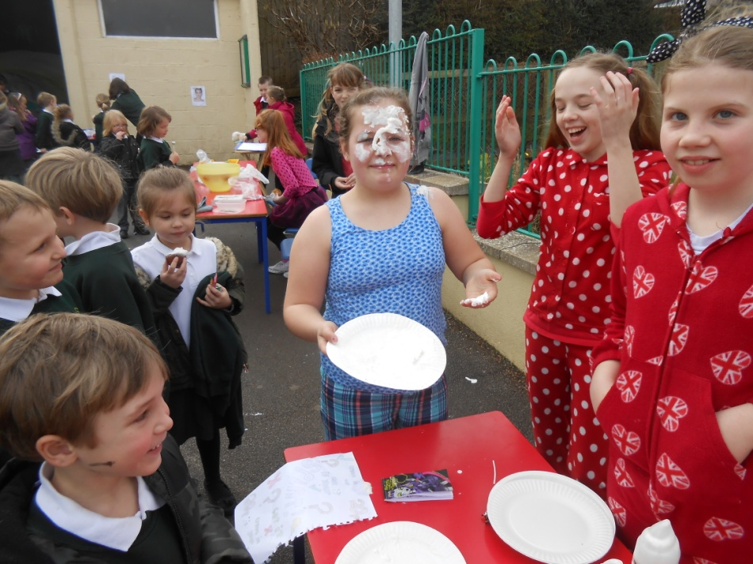
You wanted to raise money to help them to be able to go to school. You raised £417.39

Red Nose Day  Spring 2015 |  | Actions  - The ‘Whole School circle Time’ found out why there were problems with education in Africa.  - We all wanted to raise money to help.  - We all discussed how we could be funny for money.
 | Whole School Circle Time… making a difference

