History  Nurturing Nurses  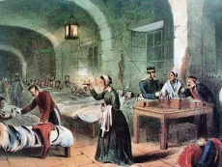  What makes a person significant?  We will be learning about the lives and influence of nurses Florence Nightingale, Mary Seacole and Edith Cavell. We will compare their lives and how their legacy has influenced modern medicine.  We will understand why is it important that we remember people from the past, |  |  | Physical Education  Future Stars – Y1 and Y2 will be developing their skills with the Future stars coach.  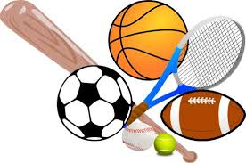  REAL PE – we will be using floor movement patterns to develop co-ordination and the combining these with static balance. |  | Computing  We will be using the laptops and iPads. We will develop our computing skills by using a trackpad, logging on and off safely and learning how to save and open files and applications.  We will be applying our skills by using a computer based art programme where we will use different colours, brush tools and effects to create computer based art work.  We will also word process to publish our work. |  |  | 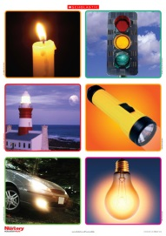  Science  We will be learning about our bodies and how to keep them healthy. We will be drawing and labeling the basic body parts and learning about our senses. We will understand how we can keep our bodies healthy by eating well, exercising and keeping ourselves clean. We will understand how keeping healthy is linked to growing and changing.  We will understand different sources of light and how inventions have changed over time.
Maths  We will be following the White Rose mastery maths planning and using the CPA approach to develop our learning.  Concrete (practical resources), Pictorial (drawing) and Abstract (numbers)  The CPA method involves using actual objects for children to add, subtract, multiply or divide. They then progress to using pictorial representations of the object, and ultimately, abstract symbols.  Children often find maths difficult because it is abstract. The CPA approach helps children learn new ideas and build on their existing knowledge by introducing abstract concepts in a more familiar and tangible way. |  |  |  | Years 1 and 2  Terms 1-2 2018/19  What Makes Us Unique?  Mrs Philpott, Miss Gibbs and  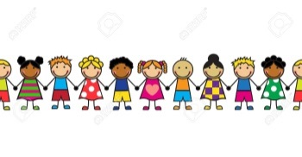  Mrs Browett |  |  | English  Fiction  What is our favourite story?  We will look at books by the author Julia Donaldson and use these to compare similarities and make book reviews.  We will be developing our story telling skills by learning the story of Little Red Riding Hood and adding actions to help us remember key words and phrases. We will use these ideas to innovate and then invent our own story. Within this story, we will focus on vocabulary used to describe settings so we can apply this in our own writing.  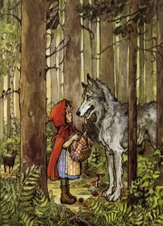  Non-fiction  We will be developing fact files and writing instructions.  Phonics and Spelling – we will continue to develop our application of phonics, high frequency words and spelling patterns in our reading and writing.
Year 1:  Place Value  Measuring and comparing parts of our bodies.  Addition and subtraction. | Year 2:  Place value  Measuring and comparing parts of our bodies.  Addition and subtraction.  Multiplication.
RE  Where do we belong?  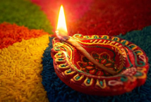  We will develop an understanding of where we belong within our families, school and the local community. We will think about the  people who make a difference to us and how we are part of a family and what that means to us. We will understand significant festivals in world religions, focusing on Hinduism and Christianity. We will retell the Christmas story. |  | Music  This term we will songs from memory with enjoyment, some expression and a sense of the shape of the melody. We will listen carefully and recall short rhythmic and melodic patterns. We will begin to become more controlled when playing percussion instruments. |  |  |  | Art  Portraits. We will use different materials and techniques the draw portraits of ourselves and others. We will have the opportunity to explore the work of Pablo Picasso, Paul Klee, Henri Matisse and Andy Warhol, and create artwork inspired by them.  Design and Technology  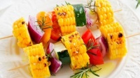  We will be learning to design and make healthy snacks. Our school caterers will be providing a workshop to help us.  Using clay we will make a Diwali lamp and will design and make Christmas decorations. |  | Geography  Our school and local area  Where do I live?  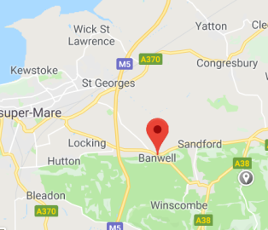  Where is our school?  Using maps and fieldwork around our school we will be finding out what our local area is like.

