Special Events  Trip to Bristol zoo.  ‘The Tiger that came to Tea’ tea party  Which animal would you like to be?  KS1 Nativity | Physical Education  Future stars coaches:  Multiskills  Gymnastics  REAL PE – we will be using floor movement patterns to develop co-ordination and the combining these with static balance. |  |  | History  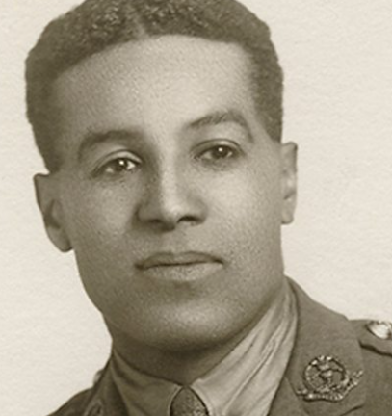  We will be learning about the life of Walter Tull who was a significant person in British and global history the first black army officer and footballer. We will be finding out about why and how Remembrance day is marked. |  | Computing  We will be using the laptops and iPads. We will develop our computing skills by using a trackpad, logging on and off safely and learning how to save and open files and applications.  We will be applying our skills by using a computer based art programme where we will use different colours, brush tools and effects to create computer based art work.  We will also word process to publish our work. |  |  | Science  We will be learning to notice that animals, including humans, have offspring which grow into adults, finding out about and describing the basic needs of animals, including humans, for survival (water, food and air). Describe the importance for humans of exercise, eating the right amounts of different types of food, and hygiene.  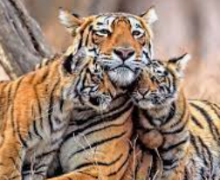  We will be sorting different animals into groups and be learning about global habitats and how animals are adapted to living in different habitats.  Will develop pur obsreravtional and engiery skills.
Maths  We will be following the White Rose mastery maths planning and using the CPA approach to develop our learning.  Concrete (practical resources), Pictorial (drawing) and Abstract (numbers)  We will be using objects for children to add, subtract, multiply or divide. They then progress to using pictorial representations of the object, and when they are secure with this we then move to using symbols. We use number lines to help us count on and back from any number. |  |  |  |  | Kingfisher and Puffin Classes  Terms 1-2  What would your animal like for tea?  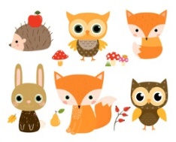  Mrs Kent and Mrs Isgrove  Miss Gibbs and Mrs Browett |  |  | English  Reading  Reading is so important and in class we teach and develop reading in many ways. It is essential that you’re child practises the skills to develop confidence and fluency.  Phonics and spelling  Wil Phonics and Spelling – we will continue to develop our application of phonics, high frequency words and spelling patterns in our reading and writing  Fiction and Non Fiction  We will be reading, writing and responding to ‘Where the wild things are’ ‘The Tiger Who Came to Tea’ and’ The Emperor’s Egg’ These books support our project and will inspire our writing. We will write and sequence sentences, retell, and innovate the stories, using them as a springboard to create and inspire our own ideas. We will also be developing fact files and writing instructions.  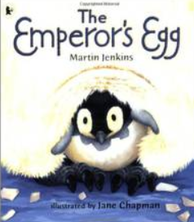  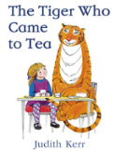  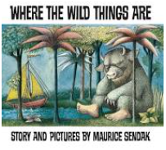
Year 1:  Number:  Place Value within 10  Addition and subtraction  Place value within 20  Geometry: Shape |  | Year 2:  Number:  Place value  Addition and subtraction.  Multiplication and addition  Measurement: Money
RE  Where do we belong?  We will develop an understanding of where we belong within our families, school and the local community.  We will think about the people who make a difference to us and how we are part of a family and what that means to us. We will understand significant festivals in world religions, focusing on Hinduism and Christianity. We will retell the Christmas story. |  |  | 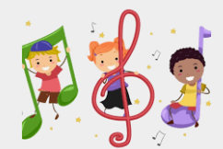  Music  We will base our music on the Charang scheme where we will listen and appraise different types of music. We find and follow the pulse and pitch and will learn to sing some songs.  We will take part in a musical nativity which we hope you will be able to join us for this year. |  |  |  | Art  We will be experimenting with different types of drawing, evaluating and improving our technique using animals as our subject. We will look at how animals have been used in art.  Design and Technology  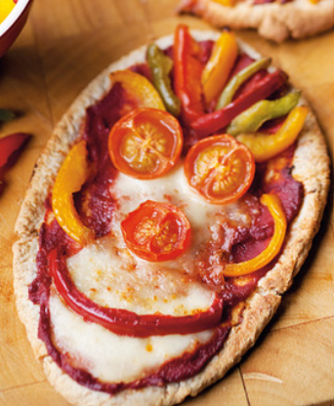  We will be learning to design and make healthy snacks and will be enjoying them at our ‘Tiger that came to tea’ tea party, |  | Geography  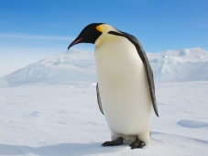  We will be developing our knowledge of the world by identifying daily weather patterns in the United Kingdom and the location of hot and cold areas of the world in relation to the Equator and the North and South poles. We will notice the changes in the seasons. We will find out where penguins live.

