What is a rainforest?
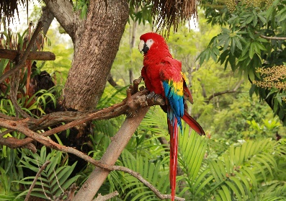
A rain forest is a place where it rains a lot the average is 350cm to 450 cm of rain. There is many things rainforest have in common. There was a boy and he was European he went to see the amazon rainforest and after a while of exploring he found people living there and he spread the news and there was more and more people coming and then the rainforest people that lived there got a disease.

What lives in the rainforest?
Animal species that live in the amazon rainforest or other rainforest. Amazon rainforests are home to 3000 different kind of fish.it has 4000 amphibians and 1300 species of bird, home to 40,0000 dark frog. Monkey and toucan are the species that stay around the canopy layer

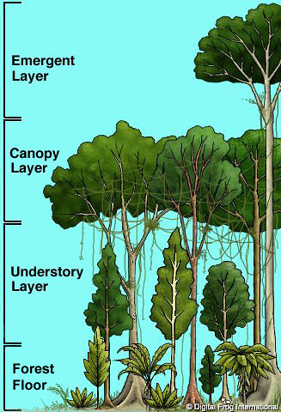
What are the layers?
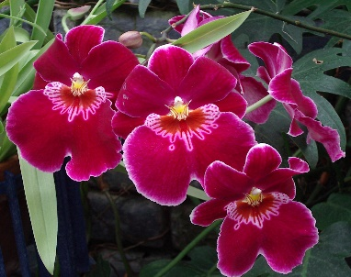
The canopy and above is the emergent layer there is also an under story and a shrub layer. To have a scientific name for the forest floor. The canopy is so thick it takes 10mins for the rain to get through

What grows there?
Plants grow especially bananas they start from herbs and turn into bananas orchids also grow anyways here is what grows in the rainforest Coffee, beans, cocoa beans, bamboo, rubber ,wood, nuts, cola, tea, avocado, oil, black pepper, lemon, lime

Why does deforestation exist?
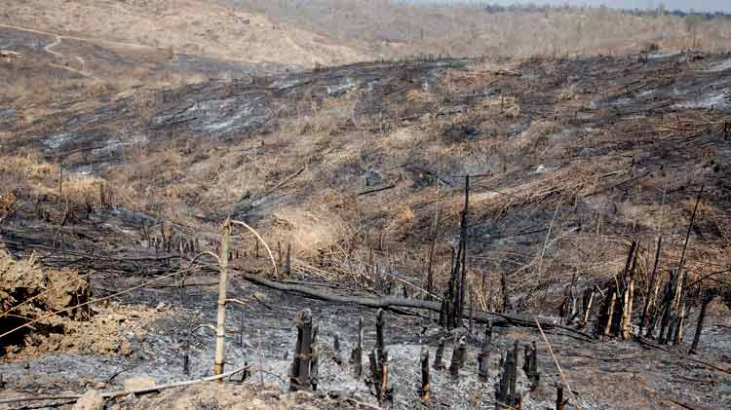
Deforestation exists because we need wood and house and other resources but there is more of a problem there cutting down the canopy layers trees its disrupting the understory but it’s being cut down a football pitch a minute some of the trees won’t grow up to the canopy layer. All nine countries should have a law about it the reason it matters is because animals are losing their homes and it’s harder for them to find food and there is less and less oxygen.

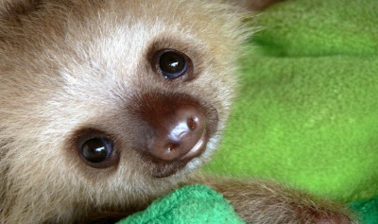
Rainforest unusual facts

In the moist rainforest in South America sloths move so slowly that algae can grow in their fur.

