What is a rainforest?
A rainforest is just as the name means a forest that gets lots of rain. It has an average of rain that can be around 250cm to 450cm of rain every year! There are four layers the emergent, canopy, understorey and forest floor.
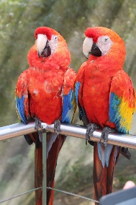
What lives there?
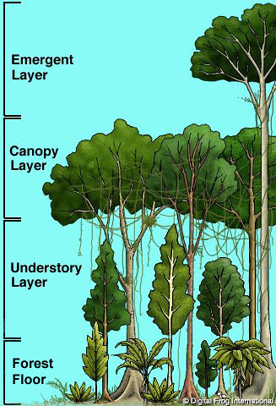
There are many different animals in the rain forest such as monkeys, jaguars, frogs and macaws animals have a big part in the rainforest if the rainforest did not have animals it would be a mess! The rain forests home to 30000 types of birds as well as 40000 types of plants.
What are the layers?
As we know there are four layers known as the emergent, canopy, understorey, and forest floor. The emergent is the tallest layer of the four its trees can be 60 meters tall. It is also the layer that gets most sunlight. Butterflies, bats, and birds live in the canopy to stay away from predators. The trees in the canopy form umbrella like trees and takes ten minutes to get to the bottom.
What grows there?
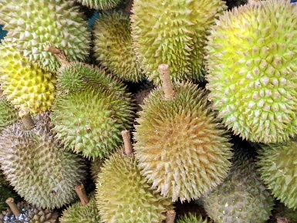
We eat many foods from the rainforest such as cacao beans, coffee beans, sugar, pineapple, and corn. Cancer treatments can be found in the rain forest too! Believe it or not there are 30000 types of food and berries growing in the rain forest right now! From trees to berries to nuts there’s thousands of foods we have not discovered yet.
Deforestation
There are many change’s going on in the rain forest that are disturbing the animals! Sometimes trees are cut down for no reason and burnt. Trees bring oxygen into our lives so we can breathe! We lose a football-pitch of trees a minute! The rainforest is getting less rain due to deforestation people that live in the rainforest don’t value it for what it is.
Conclusion
It’s going to be hard for the animals because we are destroying their homes!

