I can read 4 digit grid references: Banwell Caves are located at 38 58.  I might be able to read 6 digit grid references: Banwell Caves are more precisely located at 385 589.  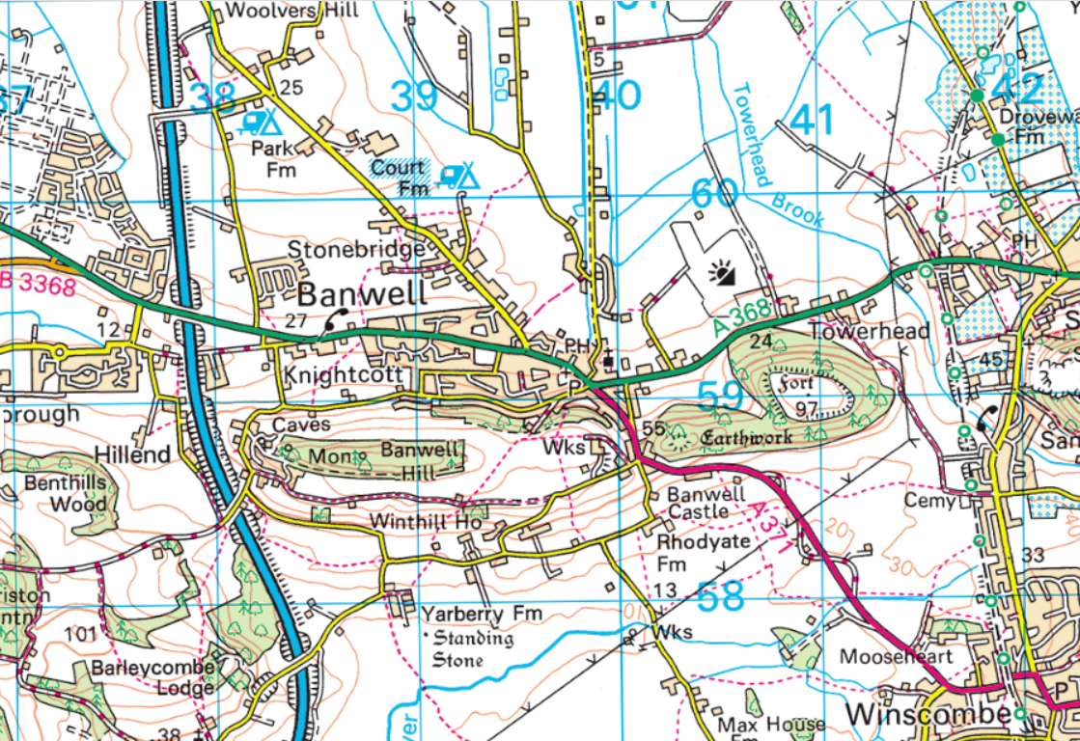 |  | I can identify the following symbols on an Ordnance Survey map:  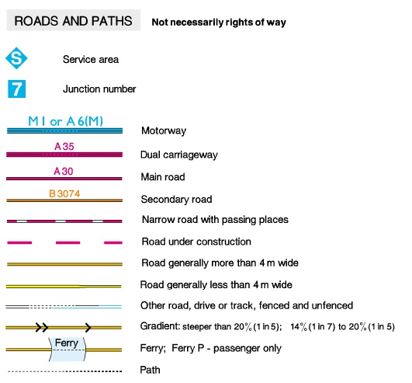  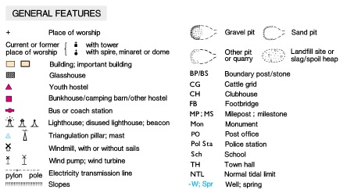
I can draw a sketch map of the local area, using my own symbols.  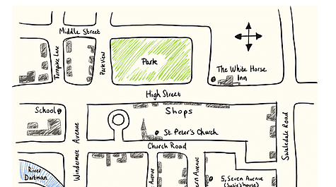 | I can interpret and draw thematic maps.  