Termly content plan: Geography
 | Terms 1/2 | Terms 3/4 | Terms 5/6
YR
Y1/2 A | Human and physical geography  Use basic geographical vocabulary to refer to key physical and human features.  Geographical skills and fieldwork  Use simple fieldwork and observational skills to study the geography of our school and its grounds and the key human and physical features of its surrounding environment.  Human and Physical Geography  Identify the location of hot and cold areas of the world in relation to the Equator.  Place knowledge  Understand geographical similarities and differences through studying the human and physical geography of a small area of the United Kingdom, and of a small area in a contrasting non-European country – Antarctica. | Geographical Skills and Fieldwork  Use world maps, atlases and globes to identify the United Kingdom and its countries, as well as the countries, continents and oceans.  Aerial photographs; devise a simple map; use basic symbols.  Locational knowledge  Name and locate the world’s seven continents and five oceans | Human and physical geography  Use basic geographical vocabulary to refer to key physical and human features.
Y1/2 B | Human and physical geography  Use basic geographical vocabulary to refer to key physical and human features.  Geographical skills and fieldwork  Use simple fieldwork and observational skills to study the geography of their school and its grounds and the key human and physical features of its surrounding environment  Aerial photographs; devise a simple map; use basic symbols. | Geographical Skills and Fieldwork  Use world maps, atlases and globes to identify the United Kingdom and its countries, as well as the countries, continents and oceans | Place knowledge  Understand geographical similarities and differences through studying the human and physical geography of a small area of the United Kingdom, and of a small area in a contrasting non-European country – Kenya  Human and Physical Geography  Identify the location of hot and cold areas of the world in relation to the Equator. | Locational knowledge  Name and locate the world’s seven continents and five oceans  Geographical Skills and Fieldwork  Use world maps, atlases and globes to identify the United Kingdom and its countries, as well as the countries, continents and oceans.
Y3/4 A | Describe and understand key aspects of:  Physical geography,  Including: rivers (Banwell river trip)  Human geography: Pond, Bridge, Pyramids  Skills and Field work,  Including: use fieldwork to observe, measure, record and present the physical features in the local area,  use maps, atlases, globes and digital/computer mapping to locate countries and describe features studied  Locational knowledge,  Including: locate the world’s countries with focus on Africa concentrating on their environmental regions, key physical and human characteristics,  Identify position & significance of Greenwich Meridian & time zones (incl night/day) | Describe and understand key aspects of:  Physical geography,  including: climate zones, biomes and vegetation belts and the water cycle.  Human geography,  Including: types of settlement and land use, economic activity (fair trade), trade links (chocolate and bananas), and the distribution of natural resources including energy, food, minerals and water.  Identify position & significance of Equator, Northern/Southern Hemispheres, Latitude, Longitude, Tropics of Cancer/ Capricorn, Prime/ Greenwich Meridian & time zones (incl night/day) | Use maps to focus on Japan  Key physical and human characteristics  Name and locate major cities  It’s geographical regions and their identifying human and physical characteristics  It’s key topographical features (including hills, mountains, coasts and rivers)  Describe and understand key aspects of:  Physical Geography  Including: Mountians (Mount Fuji)
Y3/4 B | Understand geographical similarities and differences through the study of human and physical geography:  Of a region within North America (USA)  Their countries & major cities  Geographical skills  Use 8 point compass directions to describe the location of features and routes on a map  Use aerial photographs and plan perspectives to recognise landmarks and basic human and physical features. | Describe and understand key aspects of:  Physical geography,  including: Volcanoes and earthquakes.  Locate Key topographical features. Ring of Fire | Field work (Human or Physical)  Survey artwork around Banwell
Y5/6 A | Digital mapping / Europe  Locate countries on a world map | -Locate Greece on a map  -Understand geological similarities and differences between UK and Greece  Describe and understand human geography, including types of settlement and land use. | 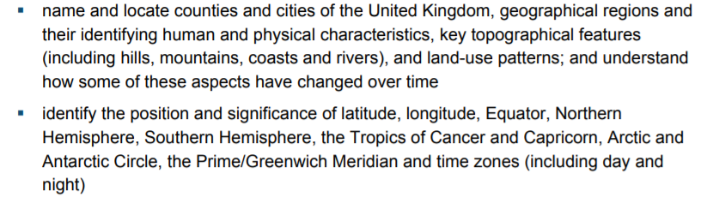  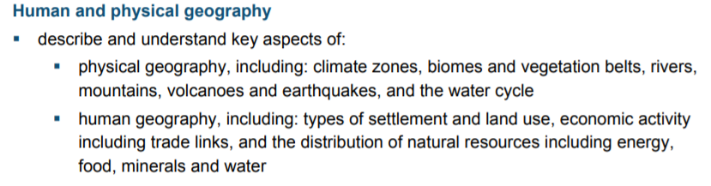  Locate world’s countries  ● Identify physical and key topographical characteristics of Antarctica on a map.  Identify key areas and map out the journey of Shackleton.
Y5/6 B | Cave & River formation  ● Water cycle  ● Locate rivers and hills on a map  ●Use field work to observe, measure and record key features of River Banwell | Digital mapping: Africa and Ethiopia  Understand physical and human characteristics of Ethiopia and compare with the UK  *Climate zones  *Poverty, homelessness, and education in Ethopia | Places to visit: Paris, Ancient Egypt  Choose one of the Seven Wonders of The World to research. You can present it in any way you choose as long as it gives lots of information about the place and why you think it was chosen as one of the Seven Wonders  If you could make a new Wonder of the World what would it be? It could be an actual place or something in your imagination. Draw it (if you wish), and tell me all about it. Why do you think it should be on the Wonders of the World list? https://www.scienceforkidsclub.com/wonders.html

