**Art, Design & Technology**

● Observational drawing

● Blitz paintings

● Construct Spitfires with wood

**Science**

Light

● How light travels

● Investigating shadows

● Taking measurements

Electricity

● Circuits

Plan a scientific enquiry

Forces

**History**

● Key events within WW2

● Understand what life was like in WW2: Homefront / rationing / evacuation

●Blitz

● Battle of Britain

**English**

● Class Book: Goodnight Mr Tom

● Diary / letter writing

● Blitz poem

● Story writing

● Newspaper report

● Instructional writing

● Debating

● Report about a hero

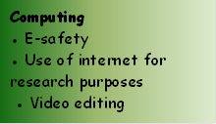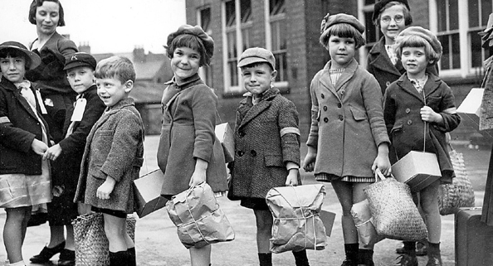

**What makes a hero? (WWII)**

**Big Idea: Courage**

**Year 5**

**WOWS**

● Life during the Homefront

● Evacuation day at East Somerset Railway

● Fleet Air Arm Museum

● Showcase learning with parents and wider community

**Maths**

● Place Value

● Written methods for addition, subtraction, multiplication and division

● Statistics

● Perimeter and Area

● Times tables

**PE**

● REAL PE – Cognitive focus on agility (reaction / response) and coordination (ball skills)

● Tennis / Tag Rugby / Netball

● Invasion games

**Geography**

● Digital mapping / Europe

● Physical characteristics of Berlin / London

**French**

● Greetings

● Who am I?

● Where do I live?

● Who is my family?

● How old am I?

● Parts of the body

● Months of the year

● Days of the week

● Numbers to 30

**RE**

What does it mean to belong to a religion - Judaism

● Journey of life

● Main practices and beliefs

● Judaism in the wider world

● Differences within the faith

**Music**

Jazz

Tunes: Three Note Bossa / The Five Note Swing

● Listen and appraise songs

● Play instruments

● Improvise

● Perform and share

● Christmas Carol concert