What is a rainforest?
A Rainforest is a place with a lot of trees and it rains lots. It is it is produces 50% of our oxygen so is very important.
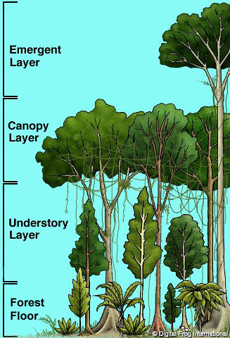
Layers of the rainforest
There are four layers of the rainforest which are called the forest floor understory emergent layer and the canopy. The forest floor and the understory are where most of the animals and insects live. This is they live there because where mast of the food is found. The track to minutes for rain to reach the forest floor is very damp humid and dark.
There are 300 different types of fish. People called indigenous people live in tribes some have not been discovered yet. The poisonous dart frog tells other animals not to eat it because the pattern on it back
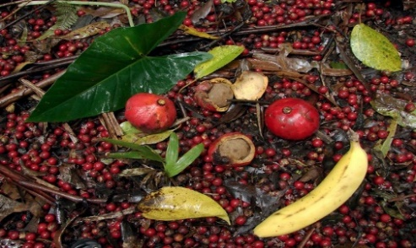
Plants and fruits
We use coffee beans nuts and coco beans that grow in the rainforest. Also bananas grow there. There are 40, 00 species of plants.

Conclusion
The rainforest started 3000 years ago it get smaller because people a chopping down the tree.

