The Amazon Rainforest

The Amazon rainforest is an amazing forest that can be found in Brazil. It’s the world’s largest rainforest and it’s so big that you can fit the UK and Ireland in it 17 times! If you ever go to the Amazon, you will be stunned on how AMAZING it is. Did you know; there are 2.5 Million different species of insects living on the forest floor and now I bet, you didn’t know that! You may want to possible about what you want to know.

What grows and lives there?
There’s a lot of things that grow there such as; Pineapple, Cocoa beans (for making chocolate), Bananas and corn. Yes, there are A LOT more of where that came from but there too much I can’t fit it in. There are a lot of tribes. There are around 4-500 native tribes there. It’s also home to around 3,000 species of fish, around 400 species of amphibians including the famous, poison dart frog everyone knows and loves. You wouldn’t believe me when I say this but, there are around or over 40,000 different plant types and if there’s that many different types of plant species, imagine how many plants there actually are! The tallest tree to ever be found here in the place of wonder is 290.3 feet tall! Just 10 feet shy of the 300 feet Statue of Liberty! You’d think that not many birds live here but, there’s actually 1,300 different bird types.

The different layers.
In the different layers there are different creatures (this kind of fits underneath the grows one huh). The creatures that live there are being disturbed because of global warming and deforestation. In the under canopy layer the leaves are really thick because there barely any sunlight so it grows its leaves to catch any bit of sunlight it can. This means that the forest floor layer (good name) can’t get any sunlight. On the forest floor there are shrubs and wilted flowers from the lack of sunlight. Did you know; it takes 10 minutes for the forest floor to get water because of the super bushy leaves on the under canopy layer. In the canopy there are skinny tree trunks but very tall (probably because it gets higher and higher).

Deforestation.
Deforestation is a BIG problem here in the rainforest. People are cutting, burning, and removing trees every single second of the day. They remove it to grow fields and fields of crop but if they’re thinking about food why don’t they think about air? Or the animals? One thing I know for sure is that they’re cutting down entire football field a minute! I wonder how the poor sloths feel about this. You’d probably scream at me for telling you this but… some deforestation is actually legal in the Brazilian code of something (forgot the name sorry). 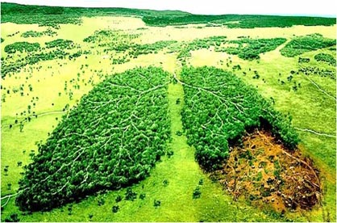

What’s the weather?
Mostly, since the Amazon rainforest is near the equator its super humid (humid means it’s that yucky rainy hot weather where you sweat more than usual). Humid is also known as a ‘moderate climate’. Since, as I said, it’s near the equator the Amazon rainforest NEVER and I mean NEVER gets cold. Well what can I say it’s hot all year round (and don’t forget it’s yucky). If you ever go to the Amazon don’t forget to bring three ice packs to keep yourself cool.

Conclusion.
As you can see the Amazon rainforest isn’t that great with weather but it’s definitely great in size. Rainforests are very precious and we need to protect them from getting cut down. This all started 13,000 years ago when the rainforest started, the animals were happy and the world was at peace. 13,000 years later global warming might take over the 6% of world the rainforests. The Amazon needs to be protected and so do the animals because there is about 3-50 million animals living there and the rate goes down a lot every year.
