What is a rainforest?
Did you know the average rain every years is 250 cm to 450cm? Also the word rainforest is just as the word means it is a forest that rains a lot. Also scientist have not found not even close to all the species of the animals.

What plants live there?
Plant are very helpful for bugs because levees are there food and also bugs ca shelter under them from wind rain and also other animals. There something that not a lot of people know you can live from food off of plants in the rainforest like coco beans coffee beans and nuts. Also plants and wood is rely helpful for building stuff like a house a shed and also a fire.

What animals live in the rainforest?
Did you know that there are a lot of different species of animal in the rainforest there are 3,000 different species of fish? Also there are a lot of animals in the understory. There also 427 mammals in the rainforest there are a lot of animals in each layers and even more sepsis in the layers of the rainforest.
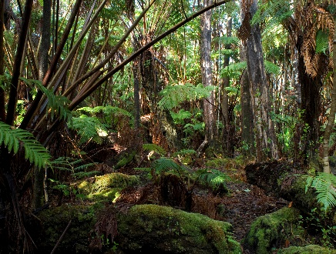
What are the layers?
All the layers are different in the rainforest but some of the layer are hot mostly the ones at the top. But the forest floor is dark so not many plants can grow there because of the darkness. On the forest floor it is so dark that only nocturnal animals go there because it’s dark there.
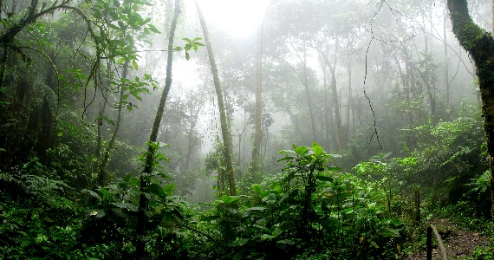

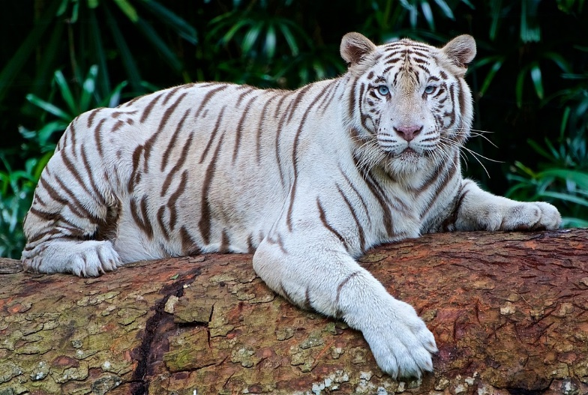
Deforestation
Lots of people are chopping down the trees in the rainforest for our activates and our daily lives. So please don’t cop down the trees. Not only is it killing animals but it is killing thousands of bugs .Also lots of people live there so they are also rely scared for the animals in the rainforest .Lots of people have to save the animals then rehome them to other green spaces.
Conclusion
Did you know there are 3,000 species of fish in the rainforest? We are losing carbon dioxide because of people chopping down trees. Lots of people are trying to stop people chopping down the trees. There are lots of levees and branches to protect the animals from other animals and from the rain.

