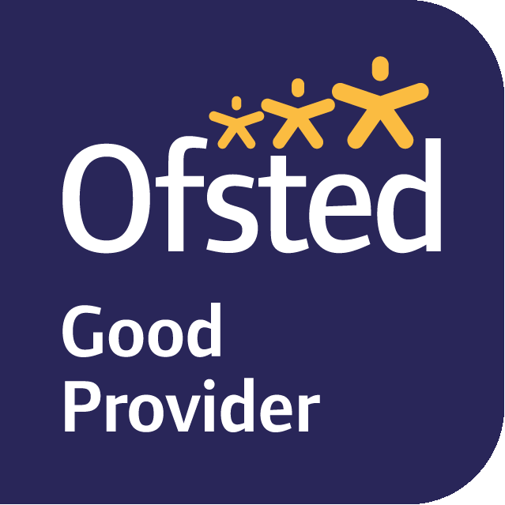
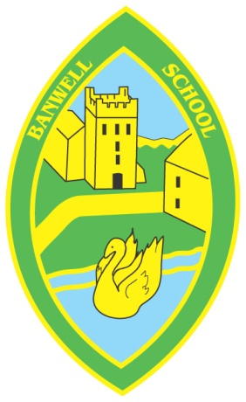
BANWELL PRIMARY SCHOOL
Belong Believe Achieve
Headteacher: Mrs. C Pocock

West Street, Banwell, North Somerset, BS29 6DB
Telephone: 01934 822498 Fax: 01934 825020
Email: office@banwellprimary.co.uk
Web: www.banwellprimary.co.uk

14 September 2018

Years One and Two – Autumn Learning Project
What Makes Us Unique?
Dear Families,
Welcome to Years One and Two. Please find attached an overview of the learning planned for the Autumn Terms within our project of “What Makes Us Unique?
During this project, we will be finding out how we are all similar but also how we are all uniquely different. Our learning will develop awareness of healthy eating and living, where we live and go to school and allow us to show off our special skills and talents. We are hoping to have a Healthy Eating Workshop delivered to us by our school meals company and will be going on a walk around Banwell Village to explore our local area. We will also be inviting families into our classrooms to share our learning. We will send out details about these activities nearer the time.
As we go along the children’s interests may take us in new directions and we will look for opportunities to develop these interests and extend their learning. If you are able to help in school or contribute your knowledge to our project, we would love to hear from you.

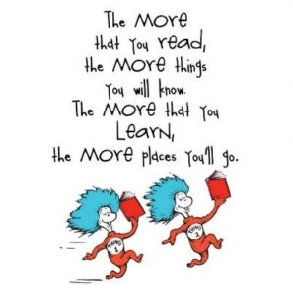
Reading: Please support your child’s progress in this vital skill by reading with them at least three times a week. This does not just have to be the reading book they bring home from school. It could be a comic, a newspaper, library book or any other book your child has at home. Reading for pleasure is so important so choosing a familiar book they enjoy is just as valuable in developing reading skills. Remember that reading to your children is just as important as them reading to you.

Please continue to write in their reading record. We will change your child’s reading book on Mondays and Thursdays when it has been recorded in their reading record that they have read at least three times. However, our aspiration is for children to read EVERY DAY. Could you be part of this above and beyond challenge?

If you would like to hear readers in school, your support would be greatly appreciated.

Maths: As a whole school, we are following a Mastery approach for the learning and teaching of maths. Children are given many opportunities to practise new skills in a variety of ways. They then apply these skills in a range of reasoning and problem solving activities and are challenged to explain their thinking.

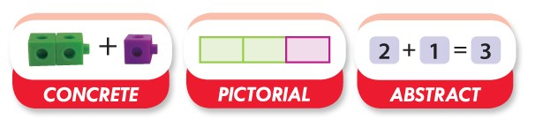

The CPA method involves using actual objects for children to add, subtract, multiply or divide. They then progress to using pictorial representations of the object, and ultimately, abstract symbols; the numbers and signs. Children often find maths difficult because it is abstract. The CPA approach helps children learn new ideas and build on their existing knowledge by introducing abstract concepts in a more familiar and tangible way. Our Maths calculation policy is on our class website pages if you would like more information about his.

Remember to check to our class website pages for links to Phonics and Maths games. Also, have a look at our ‘whooshy’ letter handwriting links. Here, you can watch how to form our 'whooshy' letters and even print out sheets to practise at home.

If you have any questions or concerns about your child’s education, please do not hesitate to come and see us.

The Year One and Year Two Team.

