What is a rainforest?
A rainforest is a forest that rains mostly at times. There are 2 rainforests there are tropic rainforests and temperate. A tropic rainforest is sometimes a forest that rains but mostly sunny and a temperate rainforest is mostly rains and snows and it is sometimes a bit hot.

What lives there?
Mostly animals live at the rainforest. But some people live in the rainforest to. The amazon rainforest is home to over 3000 species of fish and home to lots of animal’s including the poison dart frog! And the rainforest is home to 40000 plant species.

What fruit grows at the rainforest?
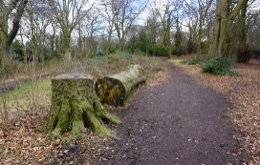
Yes food does grow there and I will tell you what grows there. Bananas coco sapling’s coffee beans pineapples avocados and nuts. Did you know that the coco saplings turn into coco beans then the coco beans are turned into coco powder then the coco powder is turned into chocolate?

Deforestation?
People are cutting down the trees they are cutting down the trees because they are clearing the area for farm animals. Every day loads of the rainforest is cut down. It is told that about 1 football pitch is cut down in 1 minute and over 60 football pitches is cut down in a day. PLEASE SAVE OUR RAINFORETS!!!

Conclusion?
There are people who we still don’t know anything about because the rainforest is so big. Sadly the trees are being cut down for wood and for parboil 50% of the world’s animal’s live in the rainforest.
So that is why we need to keep our rainforests healthy case closed… for now..........

