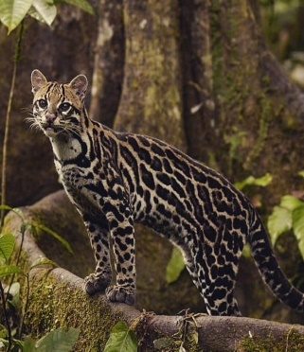
What is a rainforest?

A rainforest is just as it sounds it is a forest that gets lots of rain. If rain. It is big and full of wildlife. It reaches to the sky. The tallest trees get the most rain and sunlight. The Amazon River is 100m deep and it is the deepest river in the world.
What are the layers?
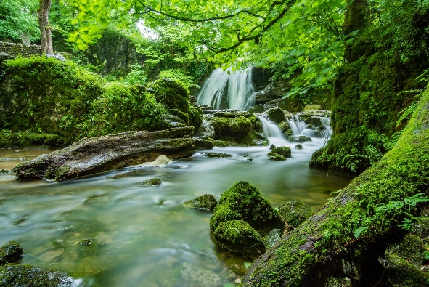
There are four layers in the rainforest and they are the forest floor, Understory, Canopy and the top layer is the Emergent layer. The tallest trees in the Emergent layer get the most rain and sunlight because they are the tallest. The Canopy is like a green umbrella the trees are so thick it takes at least 10 minutes to reach the ground. Most of the animals live here because there is lots of food there. The Understory doesn’t have a lot of animals here because most of them live in the Canopy it also doesn’t have a lot of trees here. The Forest floor is home to lots of animals with four feet some are leopards, cheetahs, lions, frog sand tiger’s just lots of animals with four feet animals.
What lives in the rainforest?
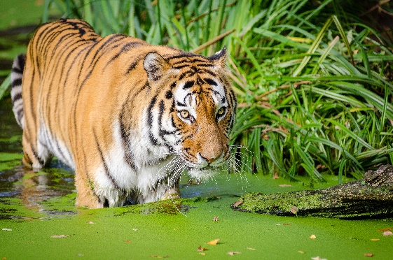
The Amazon rainforest is home to 3,000 species of fish. It is home to 378 reptiles species and 1, 3000 species of bird. There are also tribes in the rainforest that are called indigenous and native tribes. Half of the world’s plants come from the rainforests such as sugar, rice, cinnamon, coffee beans, and coco beans grow there. Half of the plants in the rainforest the world has not discovered yet.
Deforestation
Humans are chopping down trees or burning down trees just because they want to grow crops. Every minute the size of a football pitch is cut down. That means every hour 60 football pitches are cut down. The animals are getting shot if they go near the trees and that could lead to extinction and that would be bad for us.
Conclusion
There are 31, 00,000 animals live in the rainforest. The rainforest can be as hot as 91o and as low as 71o. The Amazon rainforest is the biggest rainforest in the world. What is the point of cutting down the trees because it is kind of killing yourself? The rainforest is really good because it produces all of our air.

