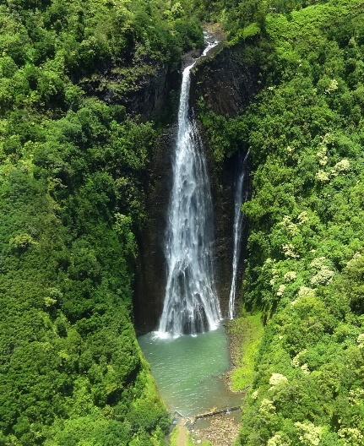
AMAZON RAINFOREST
WHAT IS A RAINFOREST?
A Rainforest is just as the name means: it’s a forest that gets a lot of rain. In fact it gets 250 to 450 a year. The Rainforest is a beautiful but a very dangerous place. It has a lot of interesting plants and animals. The Rainforest is split into four layers all for a different purpose. So let’s talk about it.
WHAT LIVES IN THE RAINFOREST
There are a lot of extraordinary things that live in the Rainforest and there some animals that haven’t been discovered yet. In the Rainforest there are 3000 species of fish and 400 species of amphibians including the highly poisonous dart frog. 378 reptile species and 1300 species of birds. Last but differently not least there are 40,000 different types of plants and 427 species of mammals. That was some of the species but in the Rainforest there are more than 31,700,000 animals there.
WHAT GROWS THERE
In the Rainforest, there are a lot of seeds and fruit that we use today. Apparently bananas only grow in the Rainforest. Coco beans grow there and the coco beans turn into seeds and that turns into coco powder and that turns into chocolate. It’s not just that but a tree called a Rubber tree lives in the Rainforest. People can get stuff from the tree to make rubber so that is how it got its name. You can also find there sugar, grapefruit, avarcardo,coconuts,tea,oil,coffe and loads more.
THE LAYERS
The Rainforest is split into four layers called the Emergent layer, Canopy, Understory and the Forest floor. The Emergent layer is the top layer and mostly gliders, bats and butterfly’s live there because it’s very high up. Fun fact the trees grow to 60m tall since they grow from the bottom. WOW. The Canopy has a lot of trees that it forms an umbrella over the rest of the layers. Most of the food is found there and quite a lot of birds live there because of the trees. The Understory is very bushy and some of the trees only grow to 3m tall. The last layer is called the forest floor. Rain only gets down there after 10minutes because of all the layers both. It is completely dark down there.
DEFORESTSTAION
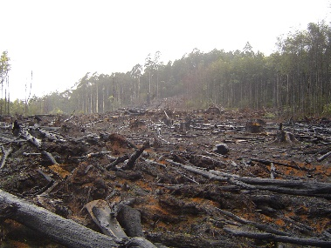
As I have been talking about how amazing the Rainforest is…..There is a threat to it. People are cutting the trees down to use it for things and sometimes they use it for nothing so it’s just burnt. It is killing the animals and scaring them. They think it’s better if they regrow the trees but there farmed so that doesn’t help. That needs to stop because very soon half our animals and plants will be thrown out the window.
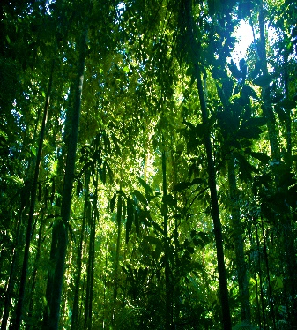
CONCLUSIUN
So that is the beautiful but dangerous Rainforest. It’s the biggest Rainforest in the world. This shows we need to protect it treat it like our homes. I find the Rainforest amazing and sometimes it can blow your mind.

