**What is a rainforest?**

A rainforest is just as the name means a forest that gets lots of rain. It has an average of rain that can be around 250cm to 450cm of rain every year! There are four layers the emergent, canopy, understorey and forest floor.

**What lives there?**

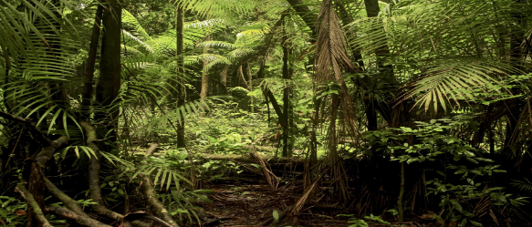There are many different animals in the rain forest such as monkeys, jaguars, frogs and macaws. Animals have a big part in the rainforest if the rainforest did not have animals it would be a mess! The rain forest is home to 30000 types of birds as well as 40000 types of plants.

**What are the layers?**

As we know there are four layers the emergent, canopy, understorey, and forest floor. The emergent is the tallest layer of the four its trees can be 60 meters tall. It is also the layer that gets most sunlight and it is cold up in the emergent. The canopy’s leaves form umbrella like leaves and takes 10 minutes’ to get to the bottom. Monkeys, birds, sloths stay in the canopy to stay away from predators.

**What grows there?**

We eat many foods from the rain forest like corn, coco beans, coffee beans, pineapple, and sugar. Cancer treatments can be found in the rainforest too! Believe it or not 30,000 types of food berries and nuts growing in the rain forest right now. From trees to berries to nuts there’s thousands of foods and berries we haven’t discovered yet.

**Deforestation?**

There are many changes going on in the rain forest that are disturbing the animals sometimes trees are cut down for no reason and burnt. Trees bring in oxygen into our life so we can breathe! We lose a football pitch a minute! The rain forest is getting less rain due to deforestation. People that live in the rain forest don’t value it for what it is .the rainforest is a paradise to the animals that live there.

**Conclusion**

It’s going to be hard for the animals that live in the rainforest because we are destroying their homes! If were destroying their homes the animals will have no place to live and nothing to eat. The animals will die out if there not eating and drinking water they will die out. If there’s no rainforest were going to have no air to breathe.