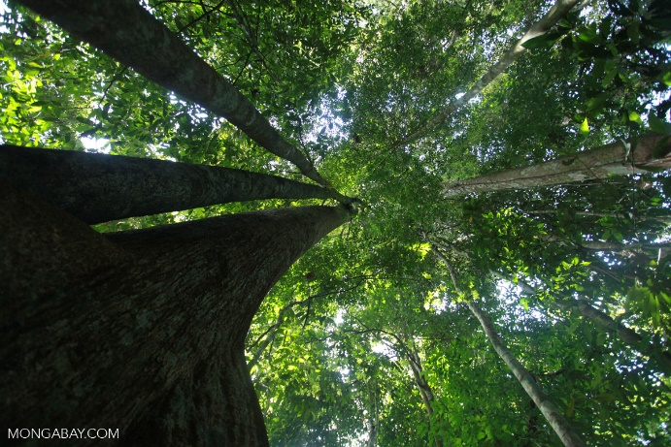
What is a rainforest?
A rainforest is big, green and full of life. It has big tall trees that stretch up to the sky! The tallest trees sit on the Emergent layer witch is the tops of the rainforests. A rainforest is just like its name because it gets lots of rain to be pacific 250cm to 450cm every year. Did you know there is a big, long river in the middle of the rainforests called the Amazon River and is 100m deep!
What lives there?
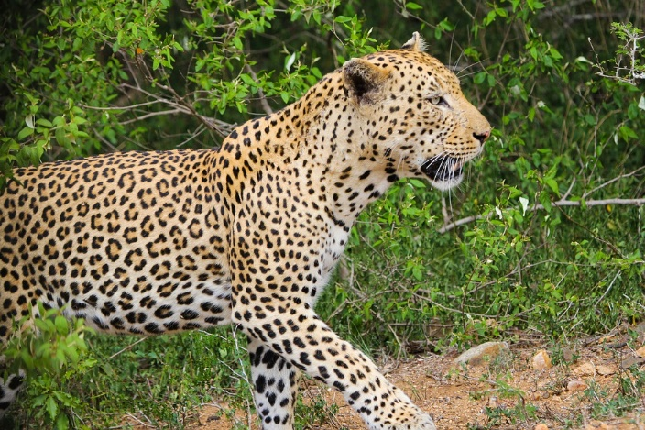
The amazon rainforest is home to around 3,000 species of fish also 1,300 species of bird and 378 reptile species. There are a few different tribes ones the indigenous tribe and native tribe. Lots of different animals live in the rainforests and here are some Toucans, butterflies, snakes, bees, chameleons, monkeys, howler monkeys, squirrel monkeys and lots more. Rainforests are also home to 427 mammal species and 400 species of amphibians.
What are the layers?
In the rainforests there are different layers and there are four layers. These four are called the Emergent layer the canopy, understory and the forest floor. The Emergent layer is the highest layer in fact they can be 60m tall! This layer will get the most sunlight and rain because it’s at the top. The canopy layer has almost no sunlight at all and has big leaves so it kind of makes a roof over lower layers and it takes about ten minutes to get rain from this layer to the forest floor. The understory is full of bushes and shrubs and is very dark and doesn’t get much rain is very hot and humid. The forest floor is dark and damp so the plants need to adapt to the dark to grow. Also millions of bugs live on this layer.
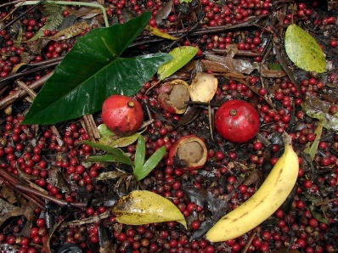
What grows there?
The rainforests are home to 4, 0000 different types of plants and people still don’t think that they have found them all! A type of tree is a rubber tree and a rubber tree releases latex that is a type of sap that goes into rubber! Coco beans and coffee beans grow in rainforest to!

Deforestation
Deforestation is very bad and deforestation means chopping down trees which is very bad because some peoples cut them down for now reason or for more crop room. Trees keep us alive because we need oxygen to breath and trees take in carbon dioxide and give out oxygen so cutting down trees is taking away oxygen! Did you know every minute people cut down a whole football stadium lot of trees!

Conclusion
Did you know the Amazon River is the 2nd largest river in the world and the Nile River in Egyped is the longest. Rosewood oil, corn, rice, sugar and cinnamon grow in rainforests. Tropic rainforest are in the middle cancer and Capricorn and temperate rainforests further away from the equator which is an imaginary line in the middle of the world and is also where it is very hot! Rainforest are very important because they give us air and protect lots of animal.

