What is a Rainforest?
A rainforest is just an s the name means it is a forest that gets a lot of rain. The rain forest is home 50 % of plants and it was around since the dinosaurs where around. The rainforest has four layers.
What lives there?
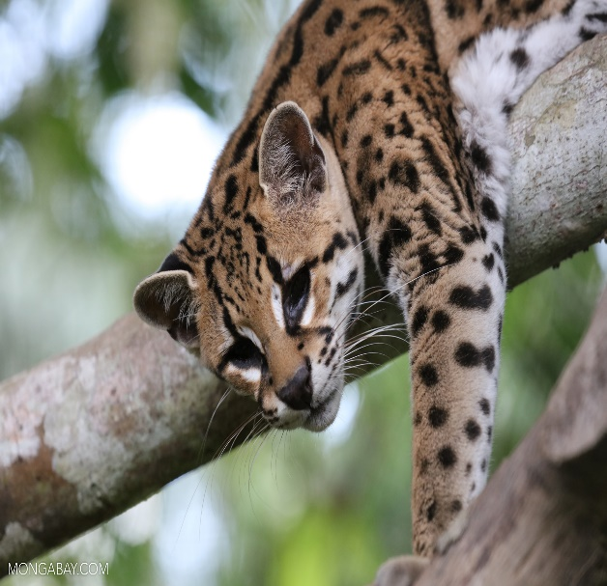
There are 3000 species of fish and 4000 amphibians. 1300 of birds 427 species mammals. 40000 plants rubber, bamboo wood coco beans, coffee beans.
What are the layers?
There is an emergent layer canopy layer under story and the last one forest floor let me tell you about them. Emergent layer very big trees live up there so they get
All the most sun to grow. The canopy layer there are lots of trees it cinder makes an umbrella so no rain can get fro. The under story it can be dark down there and be bushy. The forest floor it is very dark and very bushy and jaguars live down there.
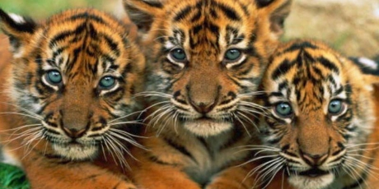
What grows there?
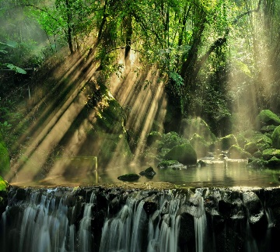
Bananas, avocado, nuts, coco beans, sugar, coffee beans .rubber trees, 40000 species of plants, trees. Fruit, soda, meat. Deforestation
People cut down trees were the animals habitats were. WE NEED TO STOP CUTING DOWN TREES . People cut down trees for lots of reasons and then burn them.
It scares animals of and they have no home anymore. Conclusion
If people cep cutting down trees we will lose oxygen . WE will lose chocolate soda and all the things we need will be gone. WE NEED TO STOP CUTTING DOWN TREES pleas give 100$ to save the rain forest.

