**Art, Design & technology**

* Margaret Mee
* Henri Rousseau
* Story book with moving mechanisms

**Class Book**

**Explorer by Katharine Rundell**

**English**

* Non- chronological report (information books)
* Poetry
* Explanation text
* Persuasive text
* Narrative story

**Music**

* Interpreting tribal music with dance and poetry.
* Compose rainforest music

**Our Green Planet**

**Why should we help save the rainforest?**

**Project (Geography)**

Understand the features of-

* Trade links
* Fair Trade - Chocolate
* Resource distribution
* Biomes and vegetation
* Climate zones
* Water Cycle
* Rainforests

**French**

* Birthdays
* Dates
* Like and dislikes
* Animals
* Wow day Tuesday 7th January
* Rainforest creatures
* Presented by Bristol Zoo
* Chocolate tasting

Celebration of Learning

* Fundraiser for World Land Trust

Thursday 2nd April

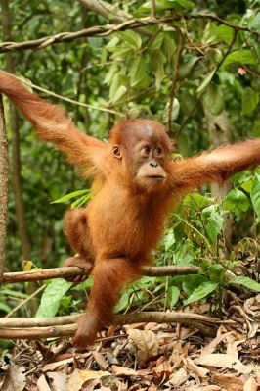

**Computing**

My First Program Unit involving using Scratch to design and create a playable computer game

**RE**

Special journeys and places

**PE**

* Swimming
* Dance Their Socks Off
* REAL PE
* Sports to School Hockey

**Maths linked to project**

* Multiplication and division
* Area
* 3x 6x 12x tables
* Fractions and decimals

**Science**

Plants

* Different parts of a plant and their functions
* Water transportation
* Requirements for life
* Lifecycle

Living things and their habitats

* Food chains
* Animal groups
* Environmental change/dangers