**History : a significant event** - Part 1 The Holocaust

● Overview of why WWII occurred; which countries were involved?

● Who were the Nazis?

● Why were Jewish people targeted?

●What was life like for Jewish families?

Part 2 - The Homefront

● Evacuation

● Rationing

●Role of women

● Blitz

● Battle of Britain

**Art, Design & Technology**

● Observational drawing (Wartime artist – Henry Moore)

● Blitz paintings

● Construct Spitfires with wood

● Make war time biscuits

**English** Class Texts : Rose Blanche

●Writing in role as Rose Blanche

● Diary writing – Write as a Jewish child in the camp

● Story writing

● Discursive – Should Rose have helped the prisoners?

Class Book: Goodnight Mr Tom

● Diary / letter writing

● Blitz poem

● Story writing

● Newspaper report

● Instructional writing

● Debating

● Report about a hero

**Science**

Light

● How light travels

● Investigating shadows

● Taking measurements

Electricity

● Circuits

Plan a scientific enquiry

Forces

Air resistance

[](https://www.google.co.uk/url?sa=i&rct=j&q=&esrc=s&source=images&cd=&ved=&url=https://www.iconfinder.com/icons/1592155/david_jew_jewish_judaism_shape_star_yellow_icon&psig=AOvVaw2-Dci39Bxo1QWTtjcj62iE&ust=1562676928268966)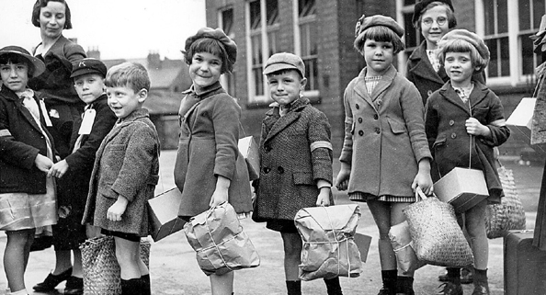

**WHAT MAKES A HERO?**

**Big Ideas: Courage, Kindness, Friendship and Tolerance**

**Year 6**

**Geography**

● Digital mapping / Europe

● Locate countries on a world map

**Computing**

●Binary code/ QR

●E-safety

●Use of internet for research purposes

●Animation (Battle of Britian

**WOWS**

● Life during the Homefront

● Evacuation day at East Somerset Railway

● Imperial War Museum

● Showcase learning with parents and wider community

**French**

Modern Foreign Languages afternoons with mixed aged groups.

**Maths**

● Place Value

●Addition, Subtraction, Multiplication and Division

● Fractions

● Geometry

● Times tables

**RE**

What does it mean to belong to a religion - Judaism

● Journey of life

● Main practices and beliefs

● Judaism in the wider world

● Differences within the faith

**PE**

● REAL PE – Cognitive focus on agility (reaction / response) and coordination (ball skills)

● Tennis / Tag Rugby / Netball

● Invasion games

**Music**

Jazz

Tunes: Three Note Bossa / The Five Note Swing

● Listen and appraise songs

● Play instruments

● Improvise

● Perform and share

● Christmas Carol concert