What is the rainforest?
A rainforest is like a forest but rains so much more it also has more layers. It has 250cm to 450 2cm of rain there are four layers that is 2 or 3 more layers than a regular one .Also 30,000 people live there 50,000 animals live there.50 % of are plants come from the rainforest and it has 25% wind speed.
What lives there?
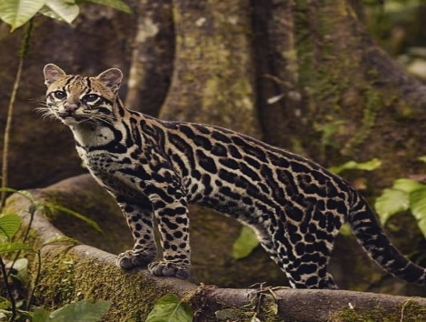
There are 3,000 species of fish, 370 reptiles, 427 mammals and 1,300 species of bird. There are tons of poisonous frogs such as dart frogs, elk, deer, tarantulas and also people called tribes. There are over 30,000 people living there in caves or building tents with branches
What are the layers?
The layers are called emergent layer, canopy layer, understory layer and forest floor. All of them are different in a good way like if your cold go to the emergent layer because it is warm. And also if your hot go to the canopy layer, if you like shade go to the forest floor and if you like animals I recommend the under story layer.
What grows there?
Things like bamboo, pineapples, coco beans, coffee beans and bananas .Orchids grow there because of the damp ground there is well. Scientists think that they have not found every single plant there so there might be new plants and flowers.
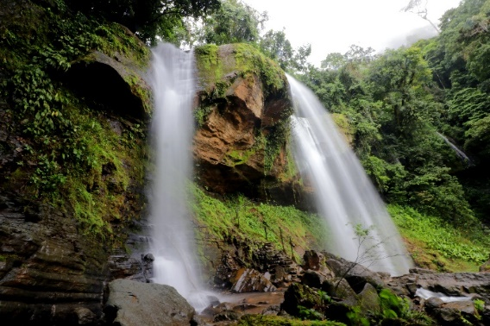
Deforestation
Deforestation is kind of like animal abuse of our trees but it’s not luckily. It is still horrendously bad. That’s actually killing our trees and it is cutting down 1 football pitch a minute and animals and people need plants like them to give us oxygen to breath. There also doing it for nothing and there ruining our beautiful planet and us and are planet.
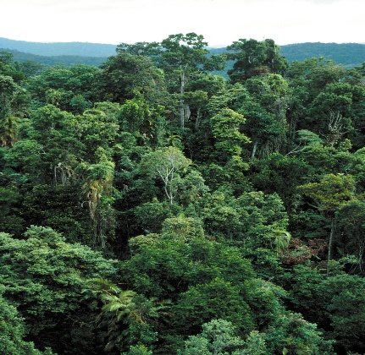
Conclusion
Did you know that rainforests only take up 3% of earth? Only 9 countries have rainforests like Madagascar, Bolivia, India and Brazil .50% of are plants come from the rainforest is well. Rainforests are important because they provide 50% of are oxygen.

