**Science**

* States of matter.
* Compare materials based on whether they are solid liquid or gas.
* Recognise that environments change and this can pose danger to living things.

**English**

* Write a newspaper report about the eruption of Mount Vesuvius
* Write a story based on the book ‘Escape from Pompeii’
* Write an explanation of how volcanoes erupt.

**Art, Design & technology**

* Design, make and evaluate a Roman shield.
* Make mosaic pictures.
* Draw a landscape portrait of Banwell
* Sculpt a Roman pot.

**Remarkable Romans**

**Big Idea: What does it mean to be remarkable?**

**RE**

Why pilgrimages and special jouneys important.

**PE**

* Dance (Dance Your Socks Off practise)
* Swimming (Year 4)
* Real PE

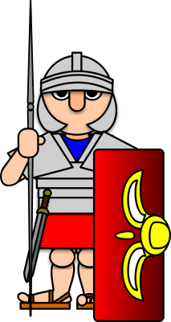

Wow Moments-

* Roman Mosaics
* Roman pottery
* Roman Centurion visit
* Adventure to find Roman remains

**Computing**

* Use4 a selection of software to publish a story.
* Use technology safely and responsibly.
* Use search engines effectively.

**Music**

The children will have an opportunity to be part of a music afternoon in both terms where they will listen, appraise, perform and compose music. They will also be learning to play the glockenspiel.

**Geography**

* Understand the features and aspects of volcanoes and earthquakes.
* Locate key topographical features
* The Ring of Fire.

**Modern Foreign Languages.**

Children will take part in a languages afternoon where they will have the opportunity to speak Spanish and French.

**Maths**

* Multiplication and division.
* Time (analogue and digital.
* Measure and converting measure.